Create React App

<https://create-react-app.dev>

npm install react

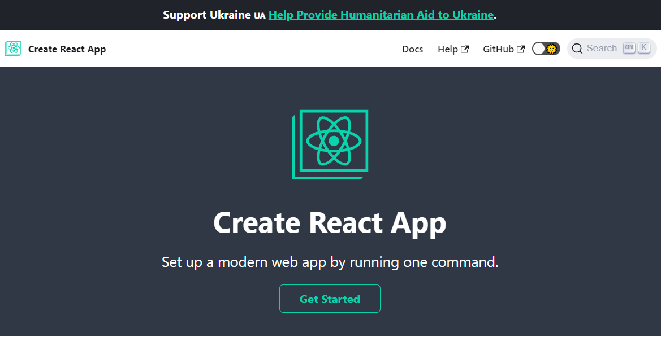

// in the past, we use: npm install -g create-react-app

// this makes things messy

npx create-react-app my-app

cd my-app

npm start

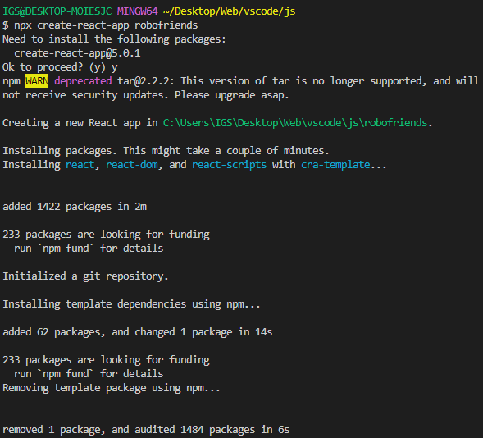

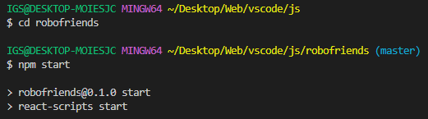

and a new React-app has been created

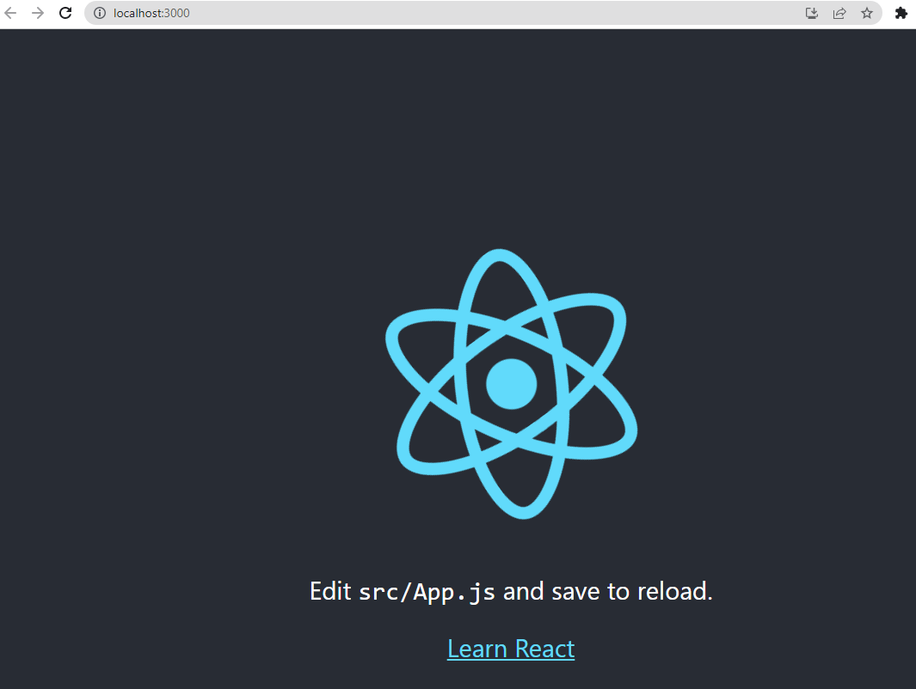

React App Folder Structure

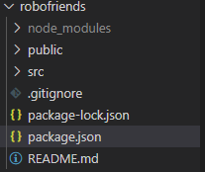

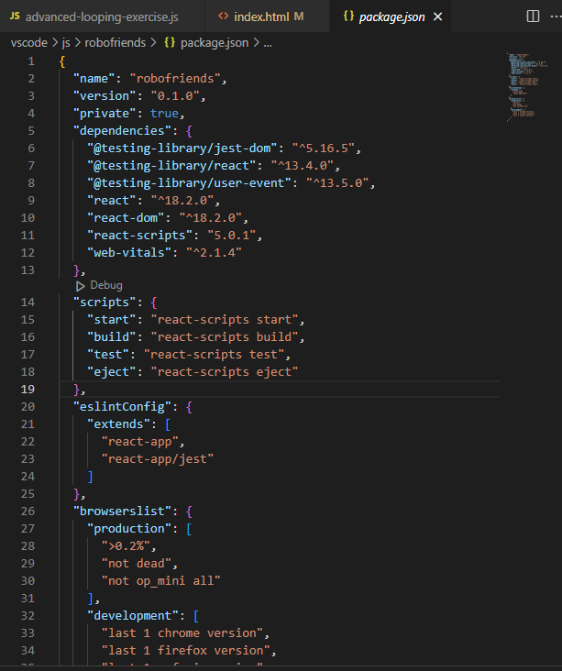

"scripts": are what we care about

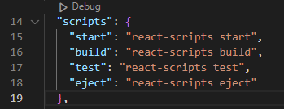

In node_modules, there're tons of modules created automatically

Go to:

react-scripts/scripts

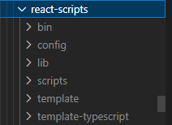

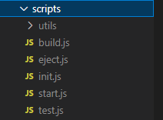

To test:

npm test

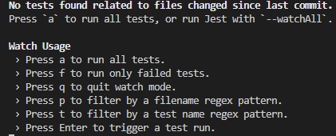

To run all tests -> a

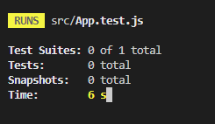

Dot file .gitignore

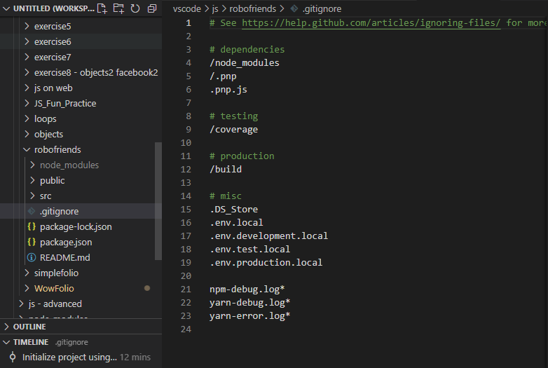

git commands -> ignore node_modules folder -> git push

We can add things here, we don't want to push to github

Important folders:

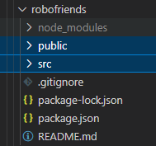

Public

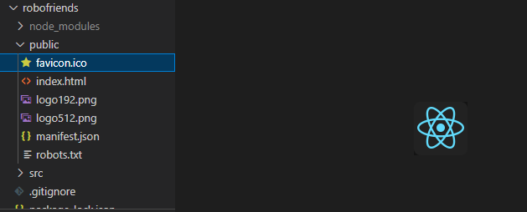

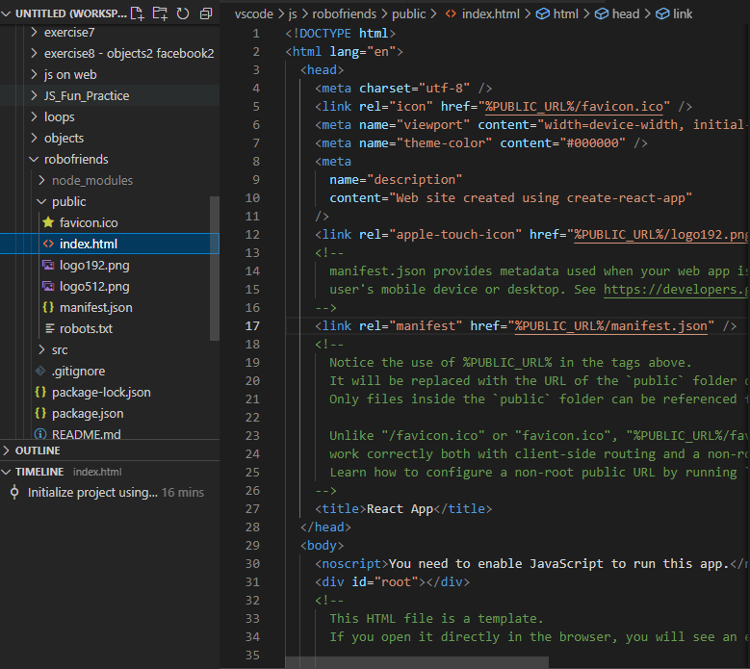

Most important part:

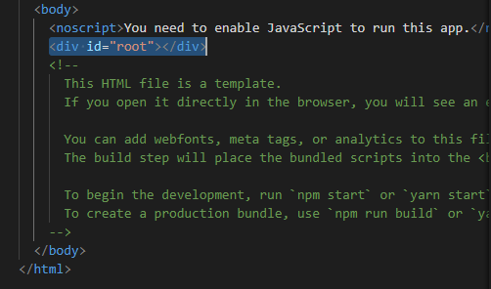

src

This is where we work on our React-app

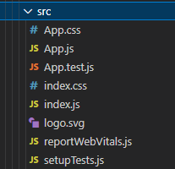

index.js

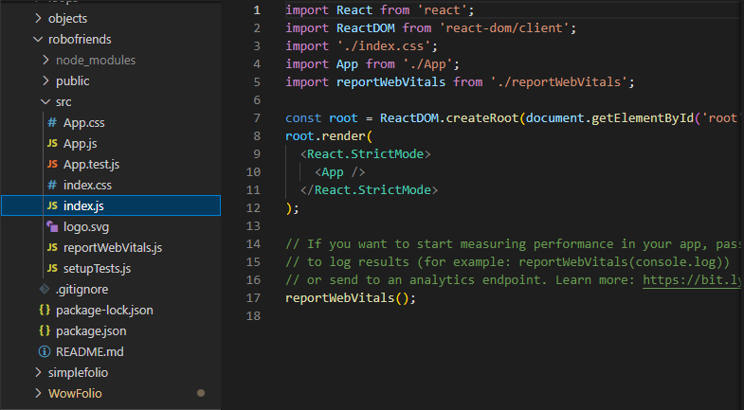

React18 update

**Stay up-to-date to React library updates**

// After running:

// npx create-react-app <my-app >

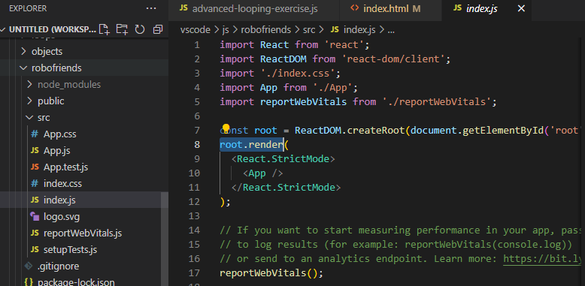

package.json file -> "react": "^ver"

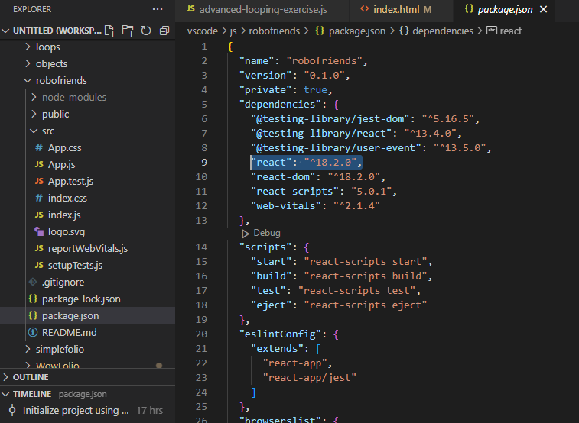

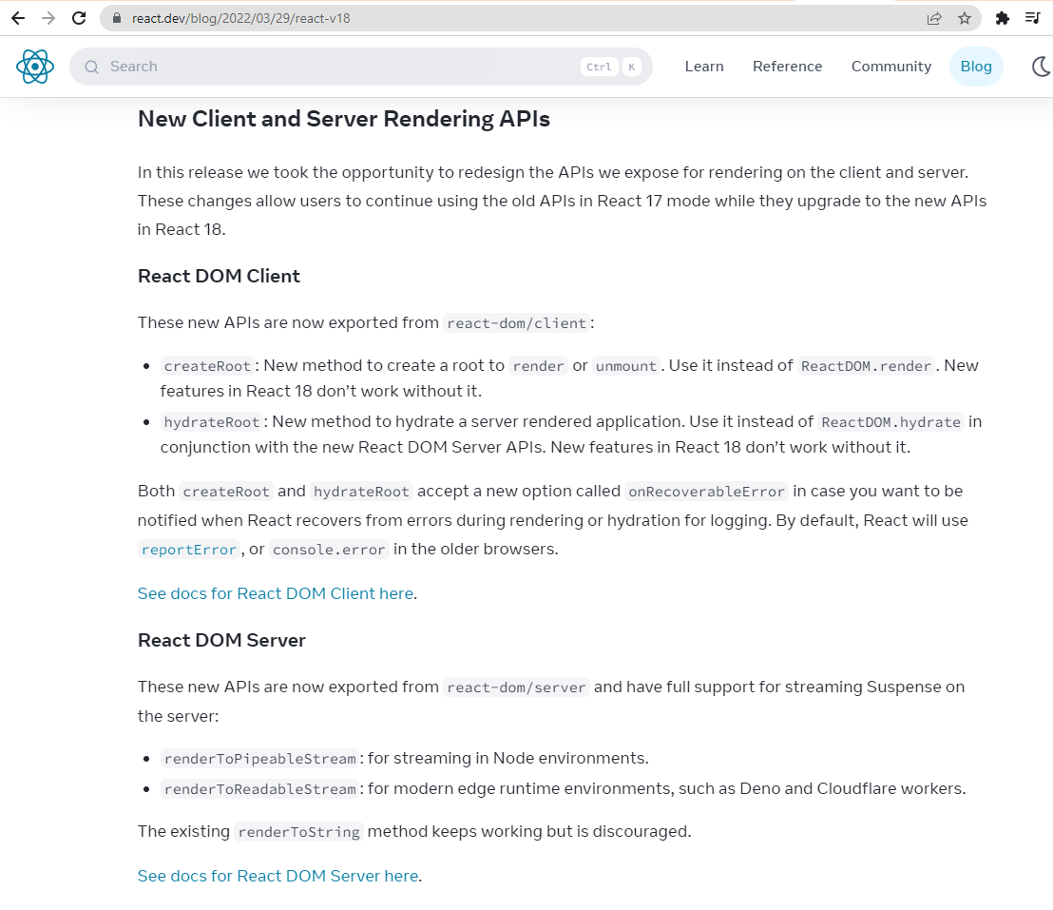

ReactDOM.render is no longer supported in React18

Use createRoot instead.

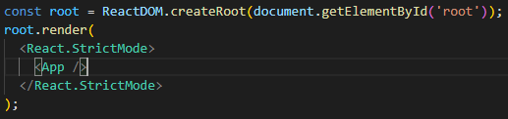

React fundamentals

public\index.html

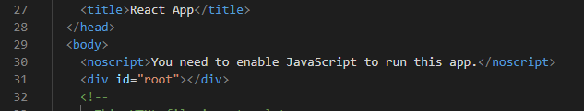

1st thing to do when building a React app:

index.js (1st thing read by computer)

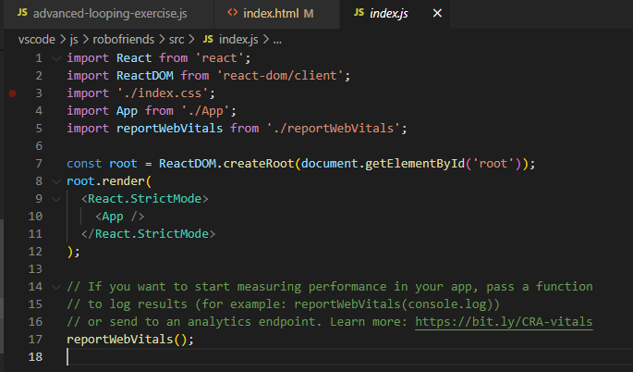

import './index.css'

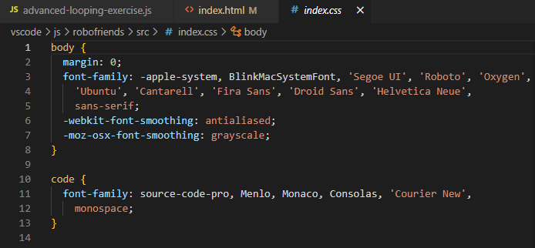

import App from './App';

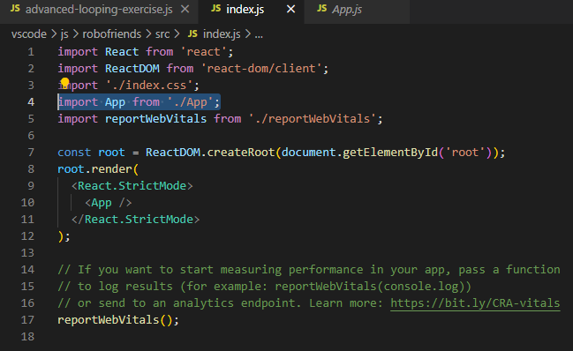

index.html

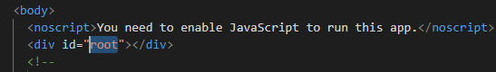

React grabs root DOM using id=root

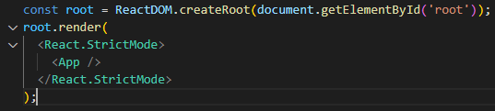

Then React renders root

<App /> App.js

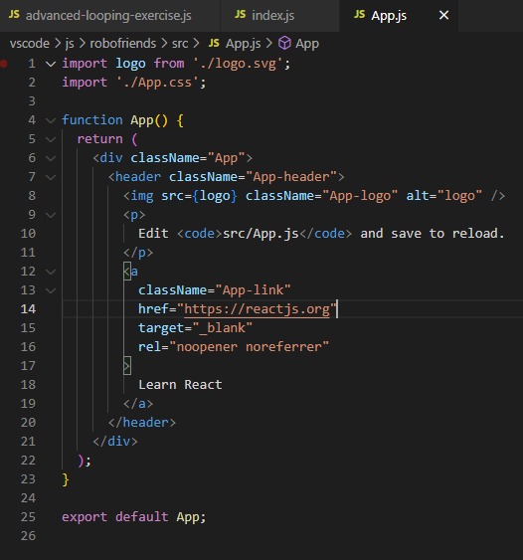

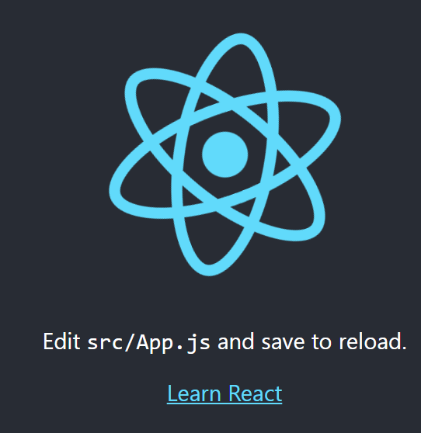

Make some changes

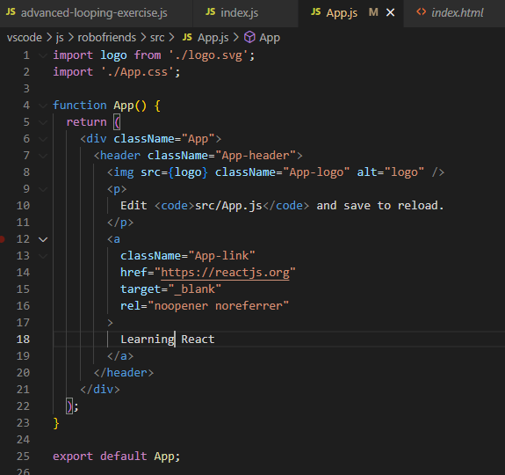

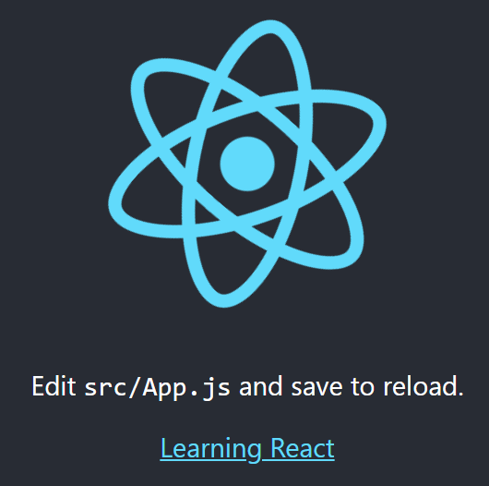

We can add things here

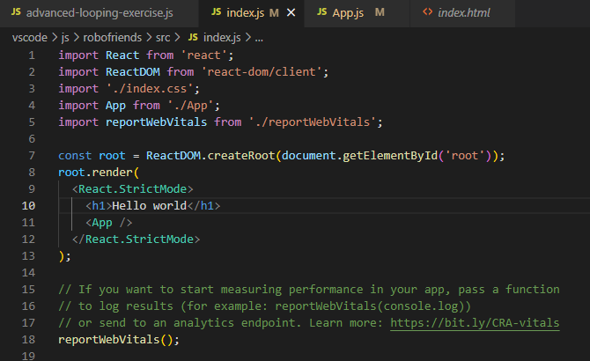

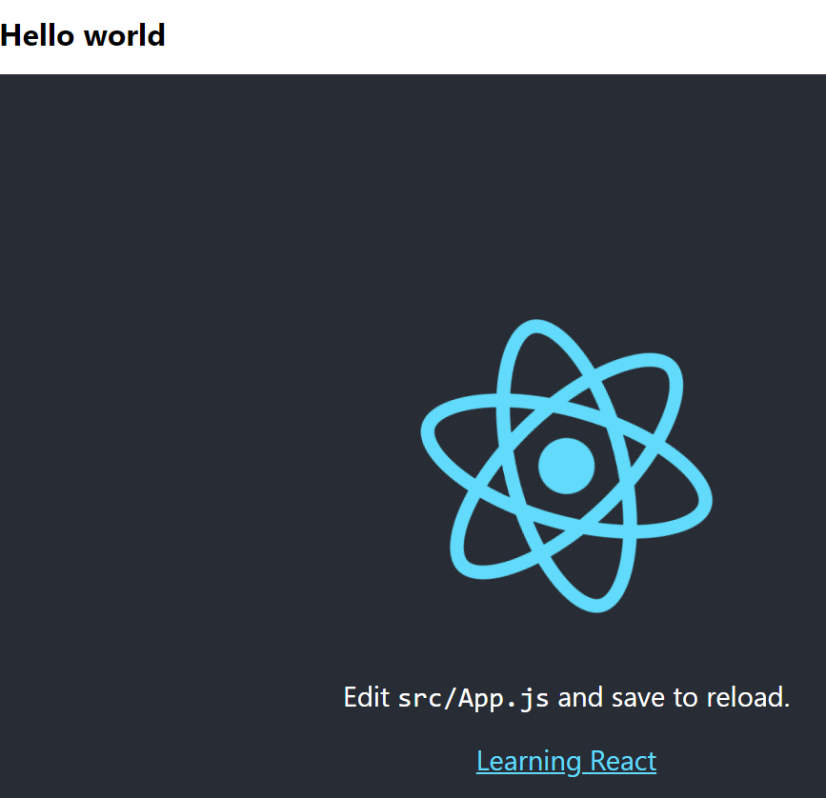

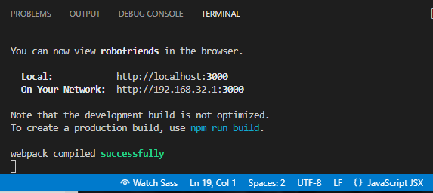

Use JavaScript JSX

Classes vs Hooks

Classes vs Hooks

Hooks = New & Exciting

Class vs Functional Apps.js

Functional component

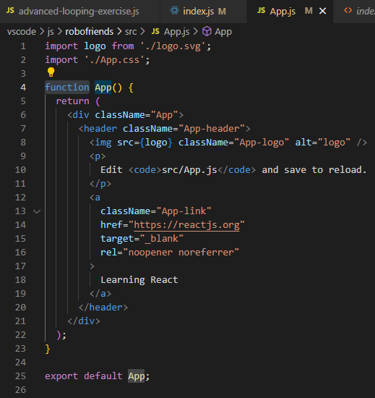

App.js

add:

import React from 'react';

function App() {

change to:

class App extends React.Component {

render() {

return (

<div className="App">

...

}

}

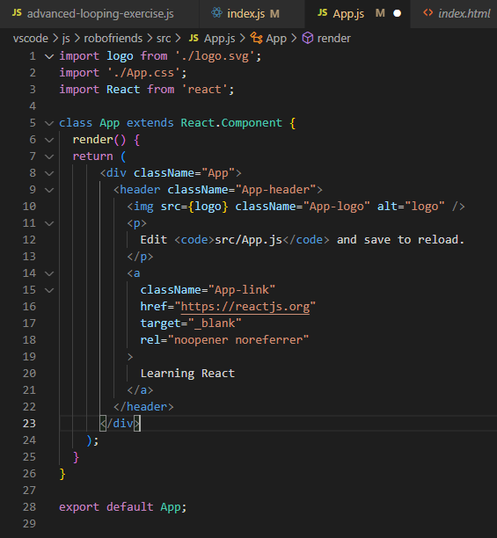

Go to index.js

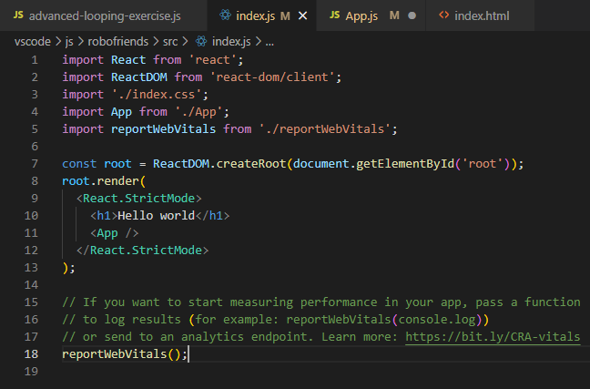

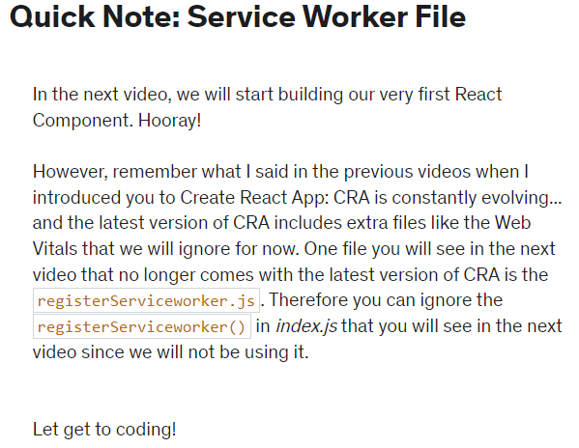

<https://developer.chrome.com/docs/workbox/service-worker-overview/>

Your first React component

Saturday, April 8, 2023

2:24 PM

Local folder created here:

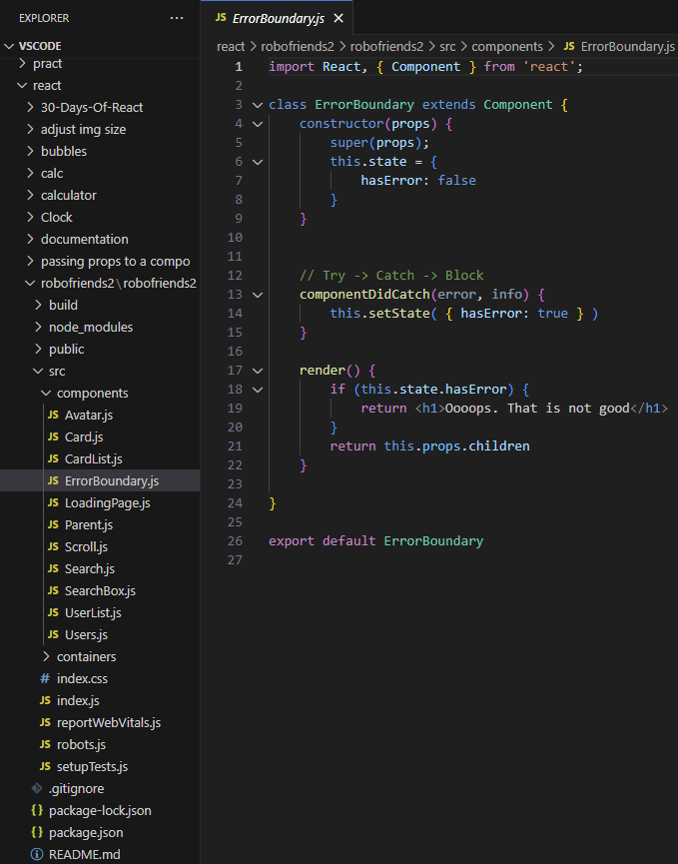

// React has Webpack for bundling

import React from 'react';

// React DOM = View library

// A Glue for React

// Reactive Native renders to mobile phones

import ReactDOM from 'react-dom/client';

// React allows to add CSS that describes the App

// App.css

// .App { }

// Only applies to what index.js renders

import './index.css';

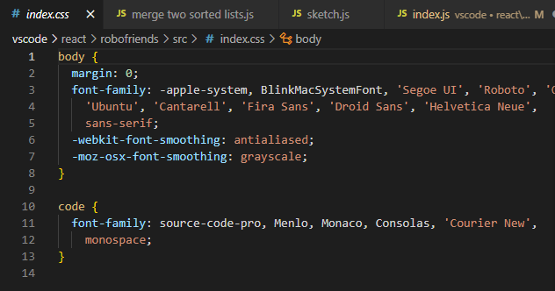

index.js

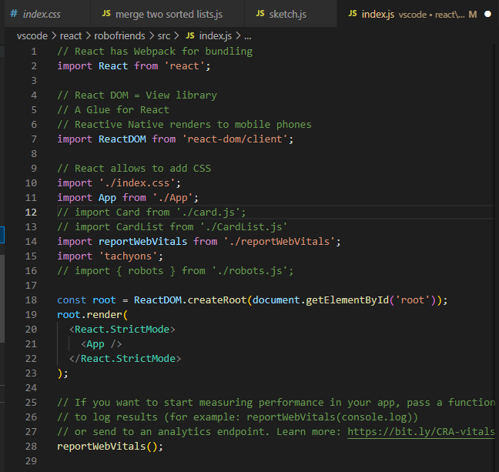

Go to App.js file:

We are creating custom components

// We are doing destructuring here

import React, { Component } from 'react';

import logo from './logo.svg';

// CSS that describes what App.js renders

import './App.css';

class App extends Component {

// Must always render something

render() {

<div classname="App">

<header className="App-header">

<img src={logo} className="App-logo" alt="logo" />

<h1 className="App-title">Welcome to React</h1>

</header>

<p className="App-intro">

To get started, edit <code>src/App.js</code> and save

</p>

</div>

):

}

}

export default app;

Comment out import App

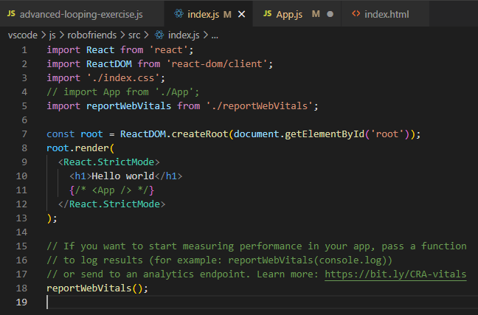

Each React component has its own CSS

i.e.

src -> App.js -> Import './App.css';

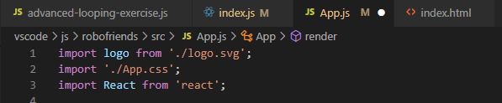

src -> index.js -> Import './index.css'

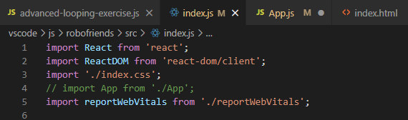

Creating new React components

src -> Create new 'Hello.js'

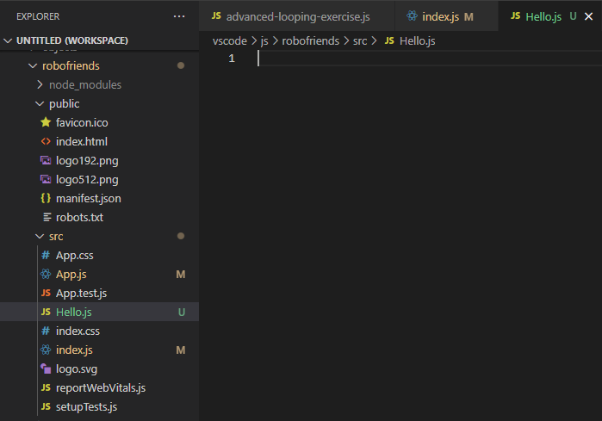

index.js

import Hello from './Hello';

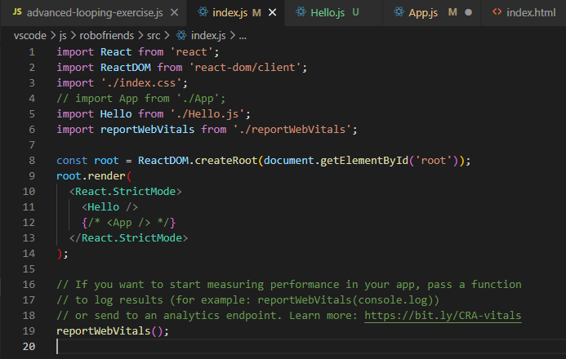

Hello.js

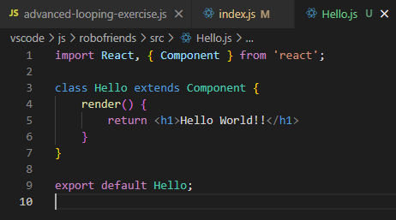

Each React component xxx.jsx has to:

export default <componentName>;

=================

Hello.js

return expects a single thing,

will give errors

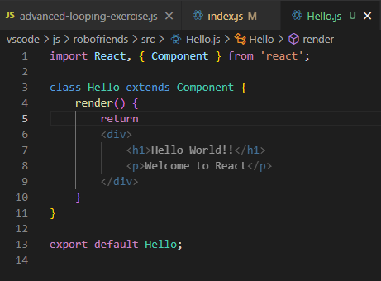

We need to use return (

contents

);

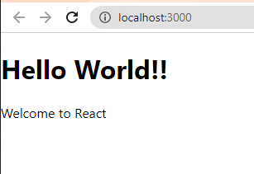

Create CSS for Hello.js

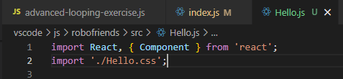

Hello.css

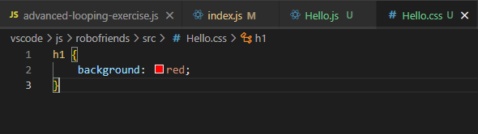

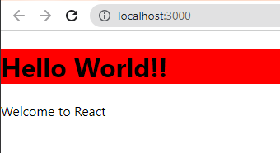

npm install tachyons

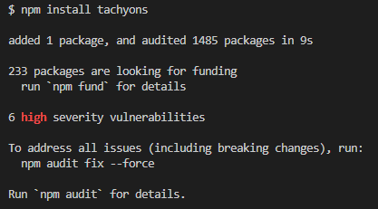

check package.json

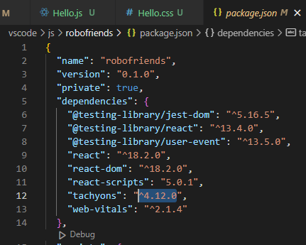

Go to index.js

import 'tachyons';

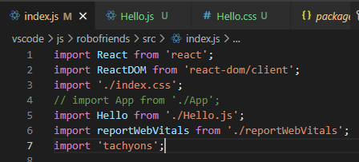

Hello.js -> edit class Hello

<div class='f1 tc'>

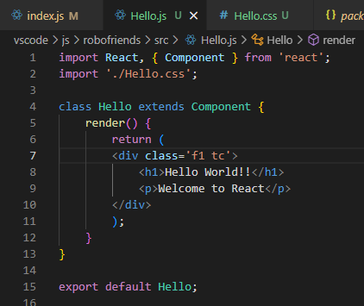

To re-render the React app:

npm start

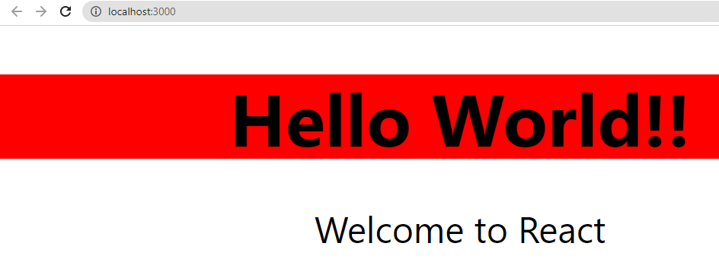

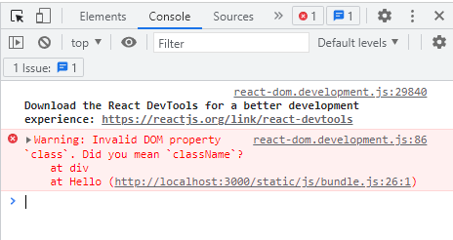

Hello.js -> <div className='f1 tc'>

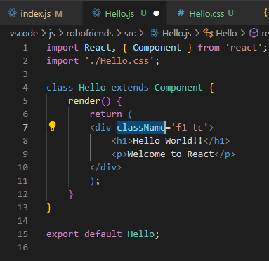

Each React component has its own functionality + styling

This fulfills separation of concerns.

writing HTML tags in Component.jsx

Virtual DOM instructs DOM to make changes only

====Adding properties to a Class

go to index.js

<Hello greeting={' '}/>

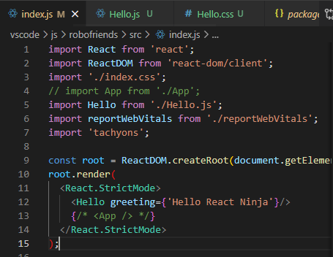

go to Hello.js

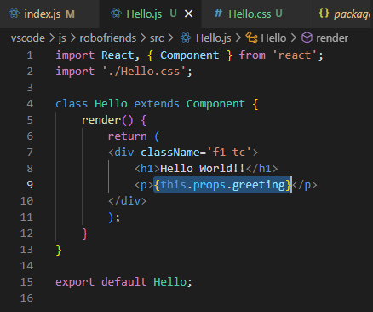

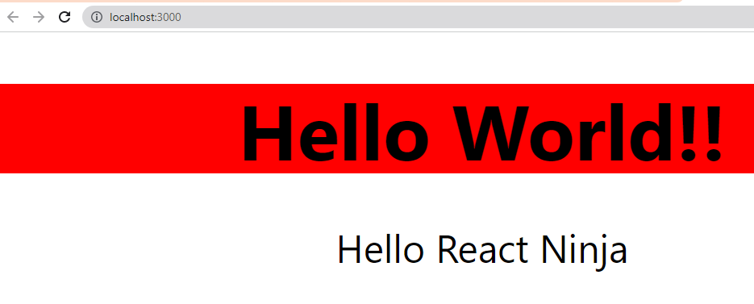

Building React app1-3

Saturday, April 8, 2023

3:14 PM

Think about Components we need to work on:

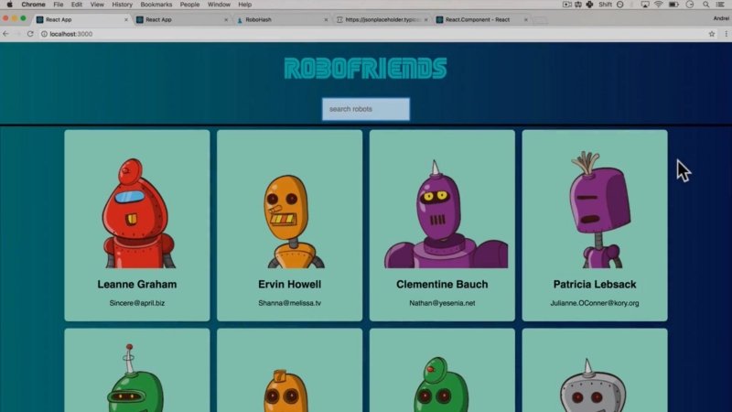

We need a page <App /> with components:

<h1>Robofriends</h1>

<SearchBox>

<CardList>

<Card>

</CardList>

-----

Let first start off by creating <Card /> component

del Hello.js, Hello.css

create src\card.jsx

Need to import React to write JSX

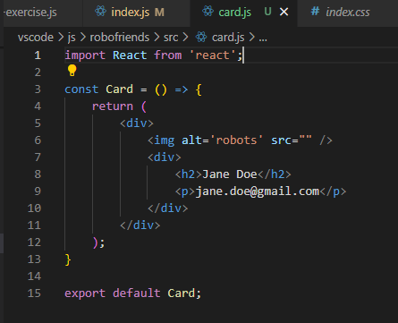

index.js:

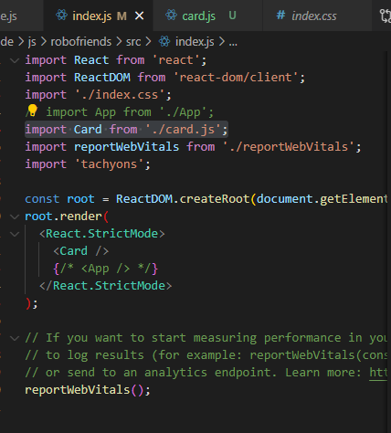

Del:

src/App.css, App.js, App.test.js, logo.svg

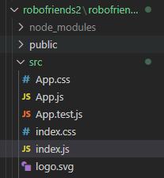

Now, we just have index.css, index.js, reportWebVitals.js

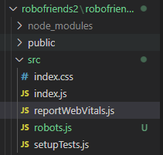

Creating a Card component -> index.js

import Card from './Card.js';

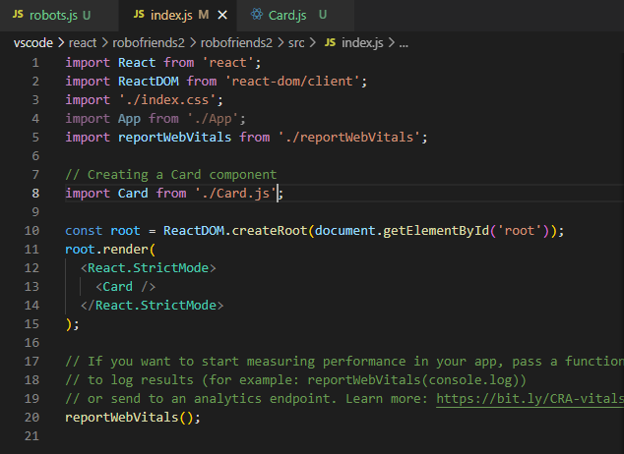

Create src/Card.js -> change to .jsx

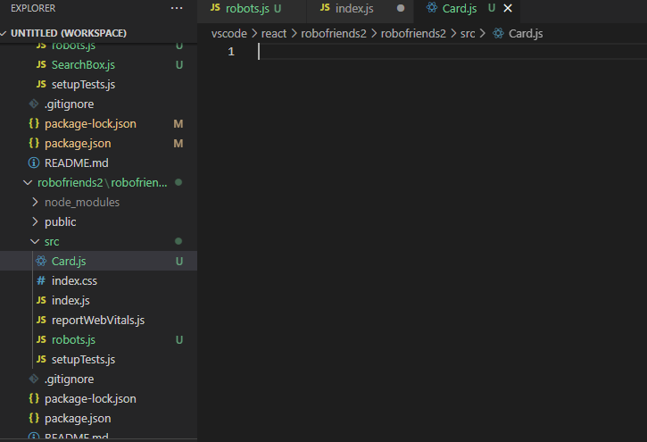

A Card will have:

1. <img>Robot picture</img>

2. <h2>Name</h2>

3. <p>E-mail</p>



Thus we have:

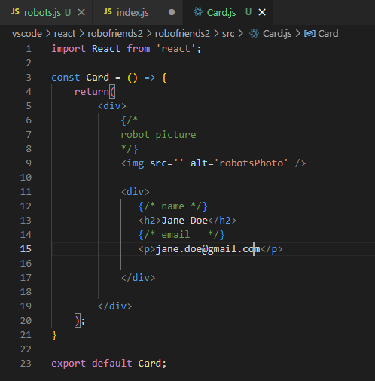

To render <Card /> in index.js :

npm start

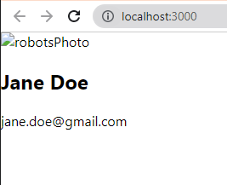

Adding src <https://robohash.org/sth>

will return a Robot

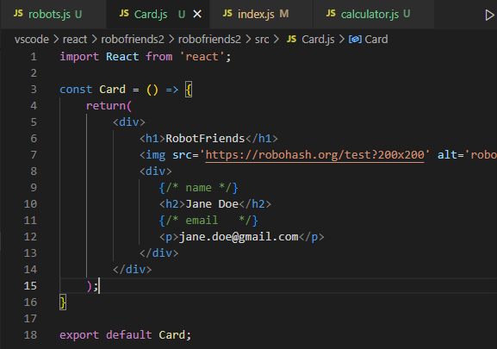

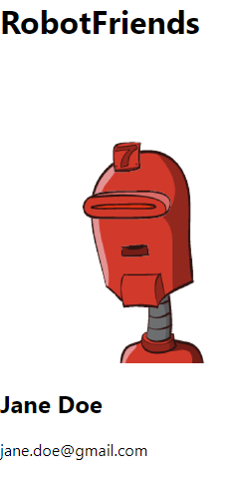

For inline JSX styling in <div className='tc bg-light-green ...'>

we use **tychion**:

<https://tachyons.io/docs/themes/borders/>

Border base:

Border 'ba'

Border Top 'bt'

Border Right 'br'

Border Bottom 'bb'

Border Left 'bl' border left

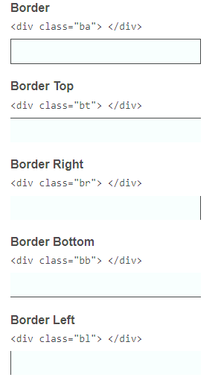

Border styles:

Dashed 'ba b--dashed'

Dotted 'ba b--dotted'

Solid (default) 'ba'

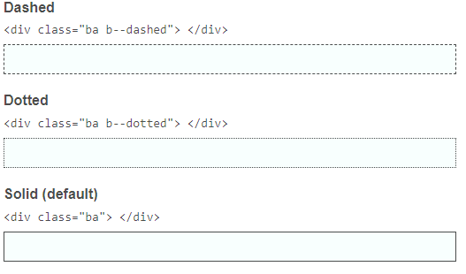

Border widths:

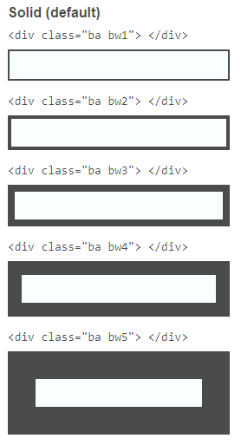

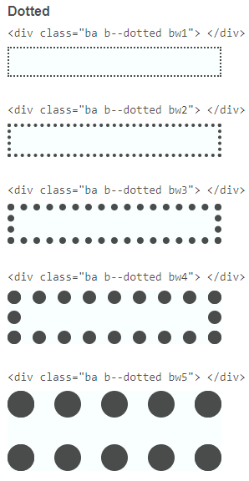

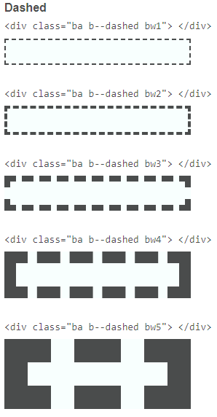

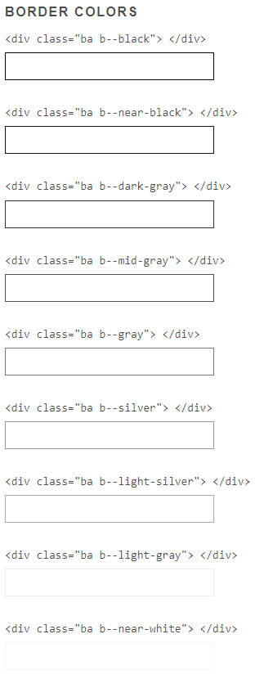

**Import tachyons**

index.js -> import 'tachyons';

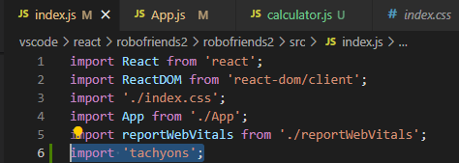

package.json -> dependencies -> add tachyons;

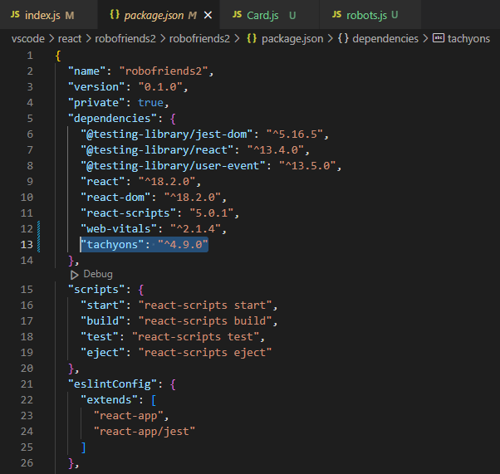

npm install

----

**For Data: id, name, username, email**

src/robots.js

data in robots.js

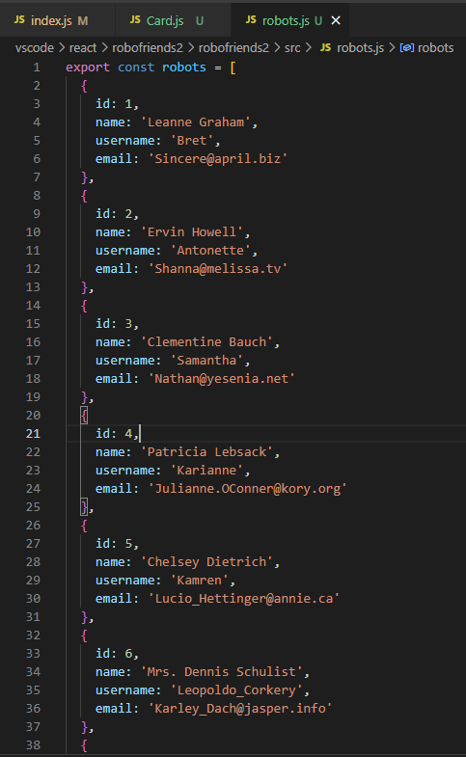

index.js:

import { robots } from './robots';

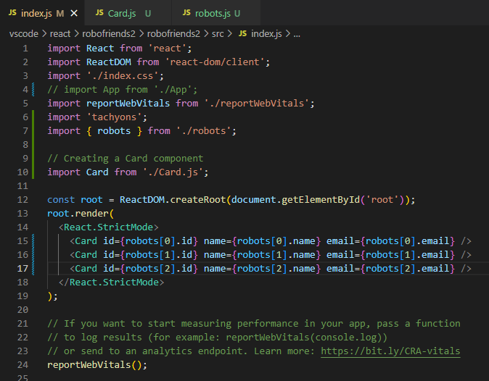

passing { props } in Card.js:

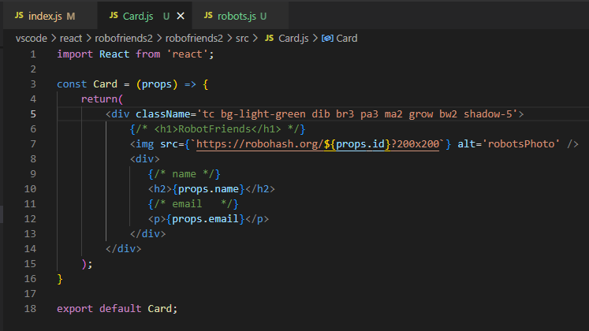

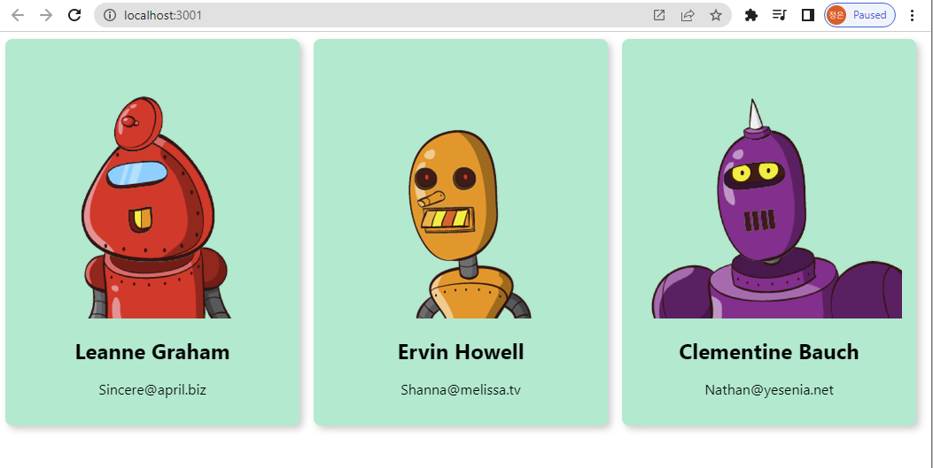

Destructuring => passing robots.js props { name, email, id } to Card.js:

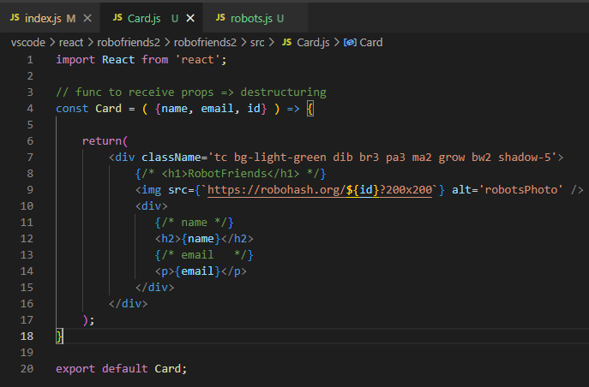

Replacing duplication in index.js:

<Card {...} />

<Card id={robots[0].id} name={robots[0].name} email={robots[0].email} />

<Card id={robots[1].id} name={robots[1].name} email={robots[1].email} />

<Card id={robots[2].id} name={robots[2].name} email={robots[2].email} />

Create CardList.js & import to index.js:

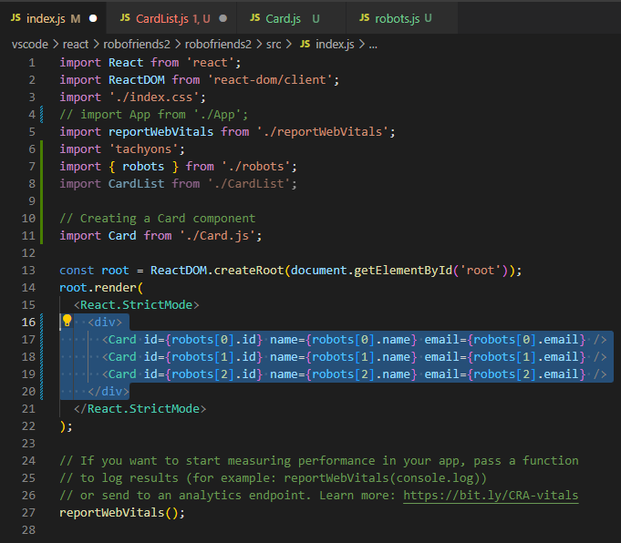

To render a CardList of 3 <Card />

Move <div>

<Card />

<Card />

<Card />

</div>

to CardList.js:

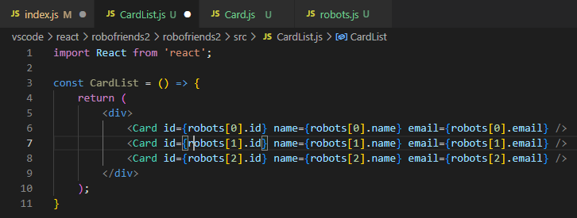

Now index.js just returns (<CardList />):

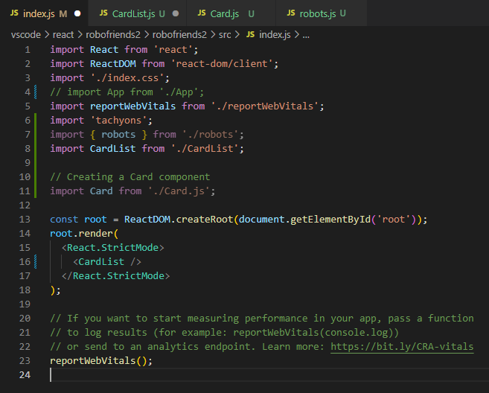

Now use { robots } from './robots'; to pass as props in <CardList />

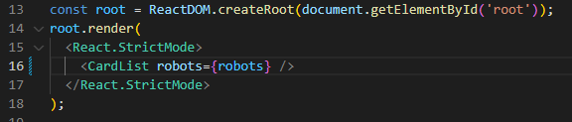

CardList.js does NOT have access to Card, robots:

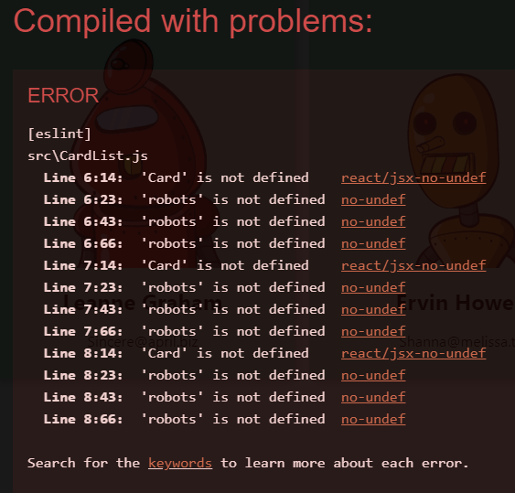

CardList.js =>

import Card from './Card';

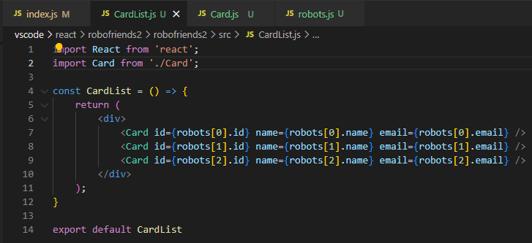

Now CardList.js does NOT have access to robots:

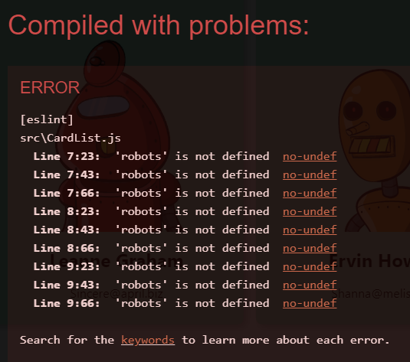

CardList.js =>

Need to pass props { robots } to

const CardList = ( { robots } ) => {}

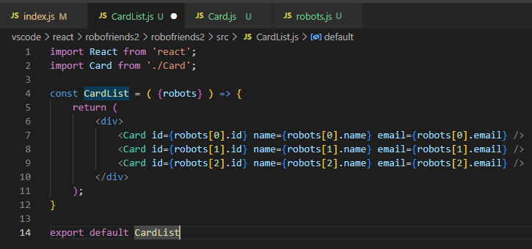

Now, need to pass all 10 robots to <CardList />

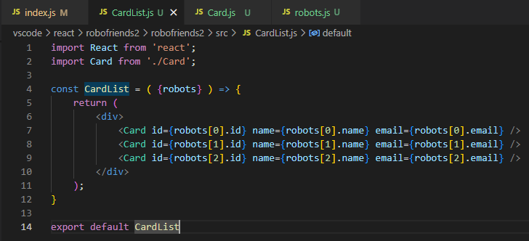

create a new variable cardComponent & robots.map(user => {return } )

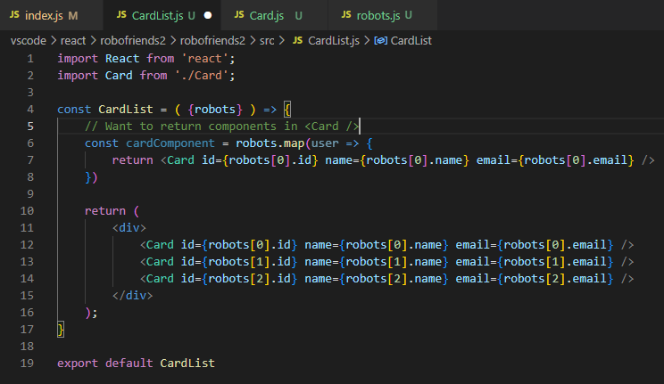

**To loop through each robot in { robots } in CardList.js**

**(return all robots in 1 <Card />**

const cardArray =

robots.map( (user, i) => {

return <Card id={robots[i].id} name={robots[i].name} />

} )

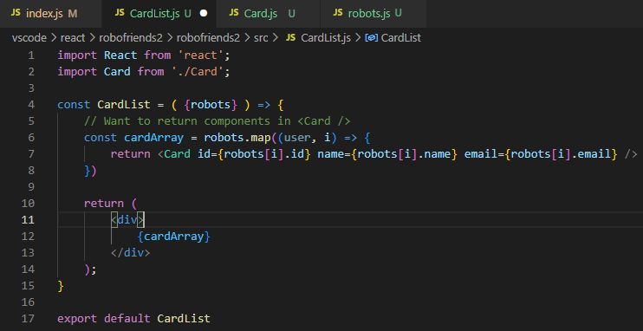

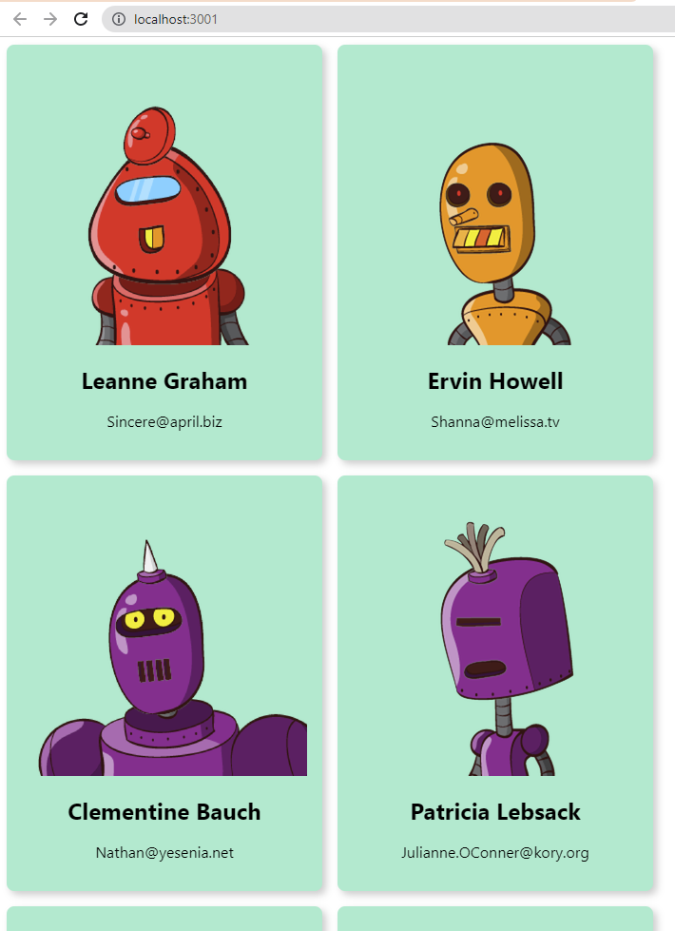

**Re-arranging return ()s to 1 single return () in CardList.js:**

**<div>**

**{**

**robots.map( (user, i) => {**

**<Card**

**id={robots[i].id}**

**name={robots[i].name}**

**email={robots[i].email}**

**key={robots[i].id}**

**/>**

**} )**

**}**

**</div>**

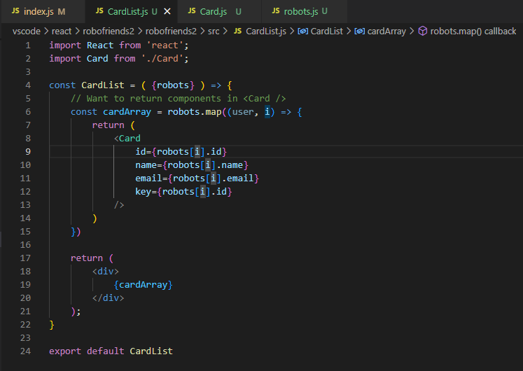

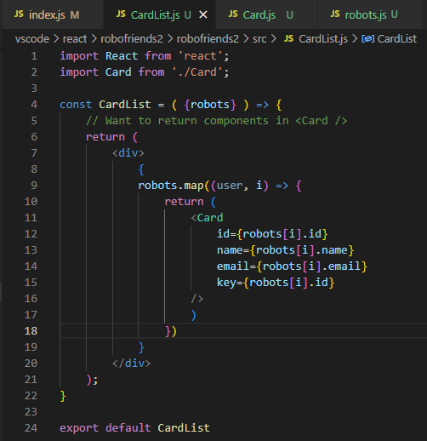

=====**Building React app3**

Now, we have <CardList /> that renders all robots as multiple <Card />

We move on to Creating a page in <App /> that will have:

<h1>Title: RoboFriends </h1>

<SearchBox />

<CardList />

Title: ROBOFRIENDS &

searchList

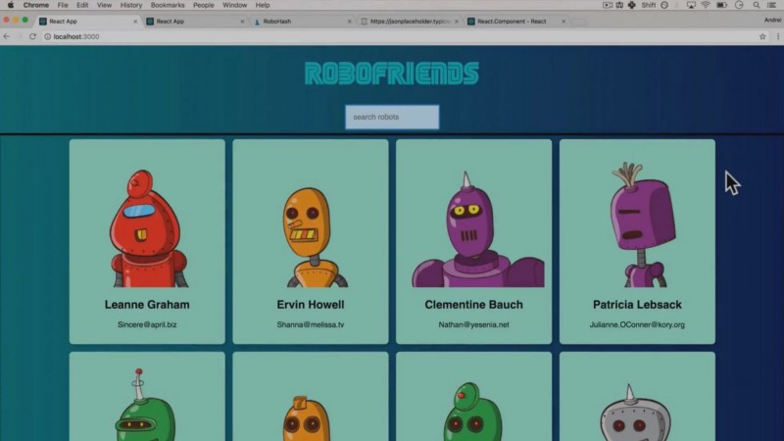

We'll need App() as a parent function



create App.js:

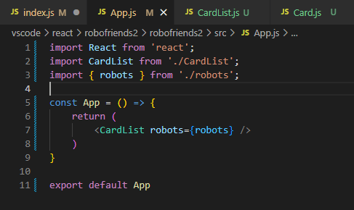

Put back <App /> in index.js:

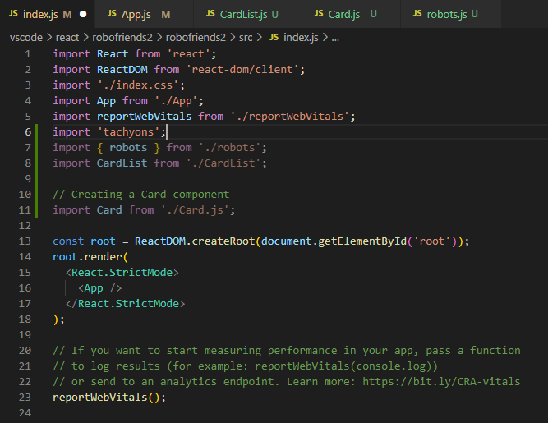

insert <h1>RoboFriends</h1> in App.js:

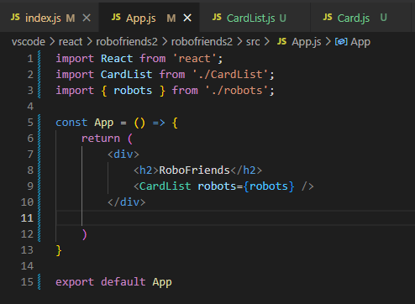

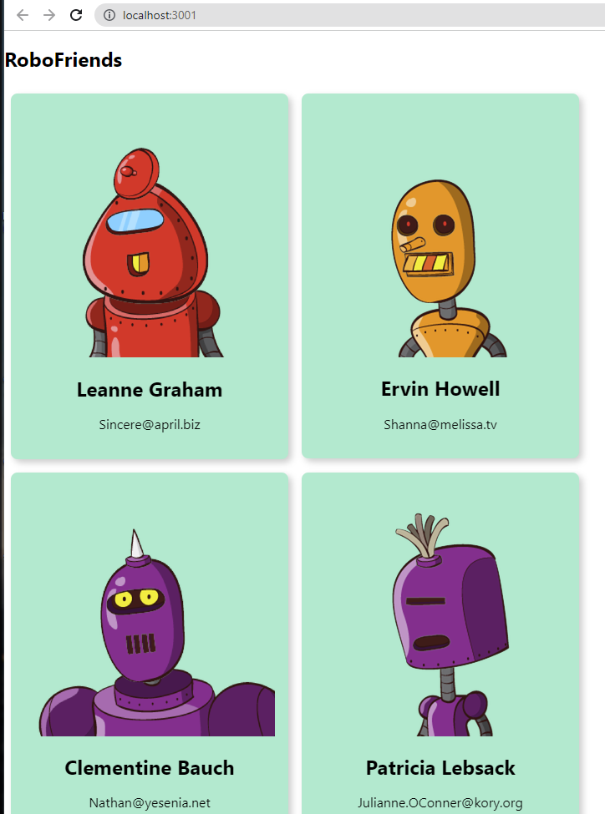

We'll create SearchBox component './SearchBox';

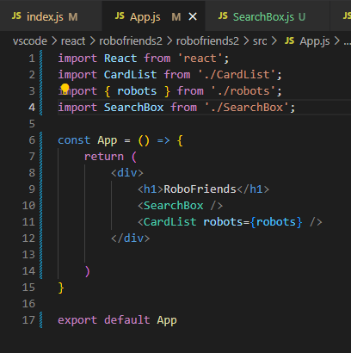

SearchBox.js:

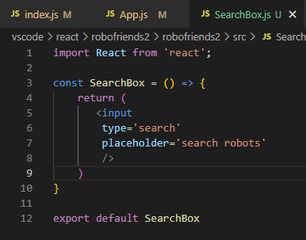

Now we have <input type='searchbox' placeholder='search robots' /> in SearchBox.js:

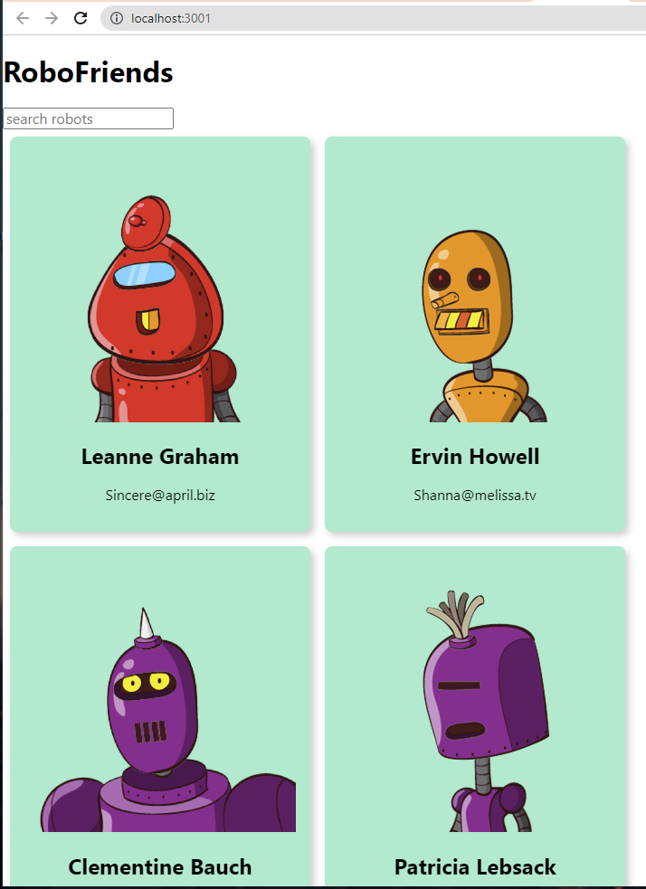

Adding some tachyons styling

className='pa2 ba b--green bg-lightest-blue grow' to <input />

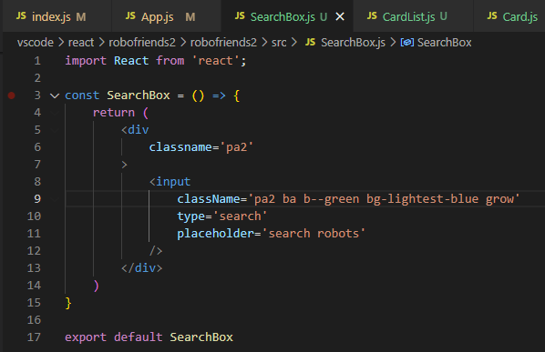

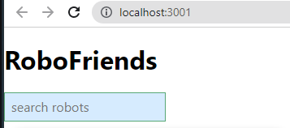

Try to center everything in App.js by adding *className='tc'* to top <div>

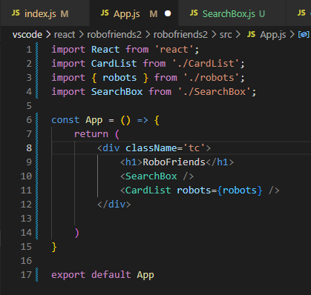

Now, we have everything centered:

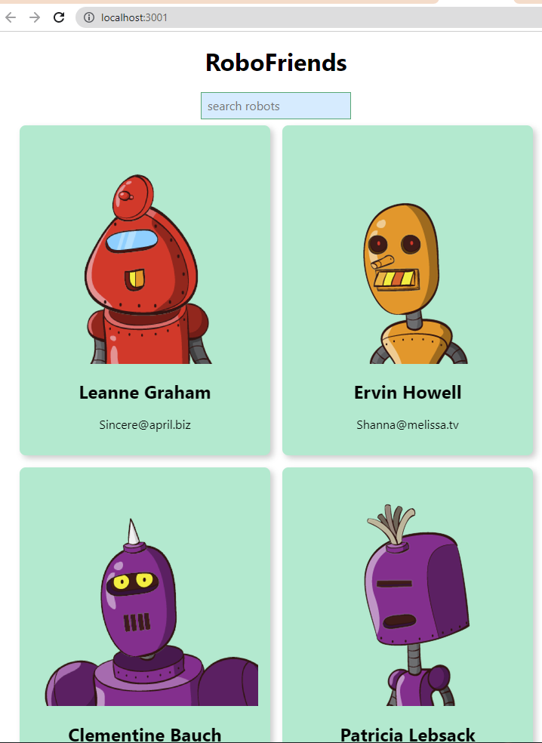

Now **<SearchBox />** needs to communicate with **<CardList robots={robots} />** via **useState**

Thus, as we type something in SearchBox onChange => return the searched robots by name

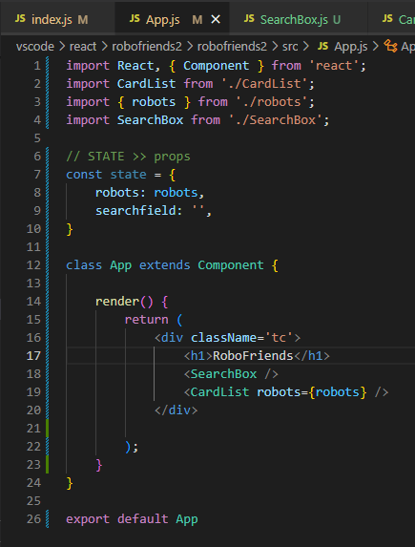

Need to create onSearchChange(event) {} to record changes in SearchBox

We'll need to pass props 'searchChange' to <SearchBox />

<SearchBox searchChange={this.onSearchChange} />

**onSearchChange(event)** { console.log(event) }

will **listen to text changes in <SearchBox /> & Log changes**

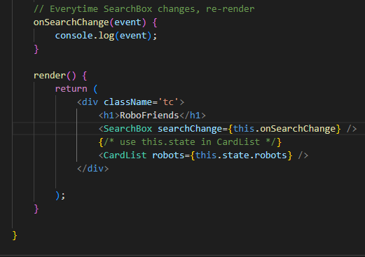

Then **declare props { searchChange } in SearchBox.js**:

**See how searchChange as a prop is passed to SearchBox func:**

const SearchBox = ( { searchChange } ) => {

<input

onChange={searchChange}

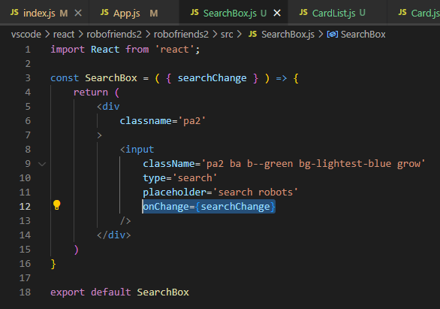

Now, as we type something in <SearchBox /> => console.log(text changes)

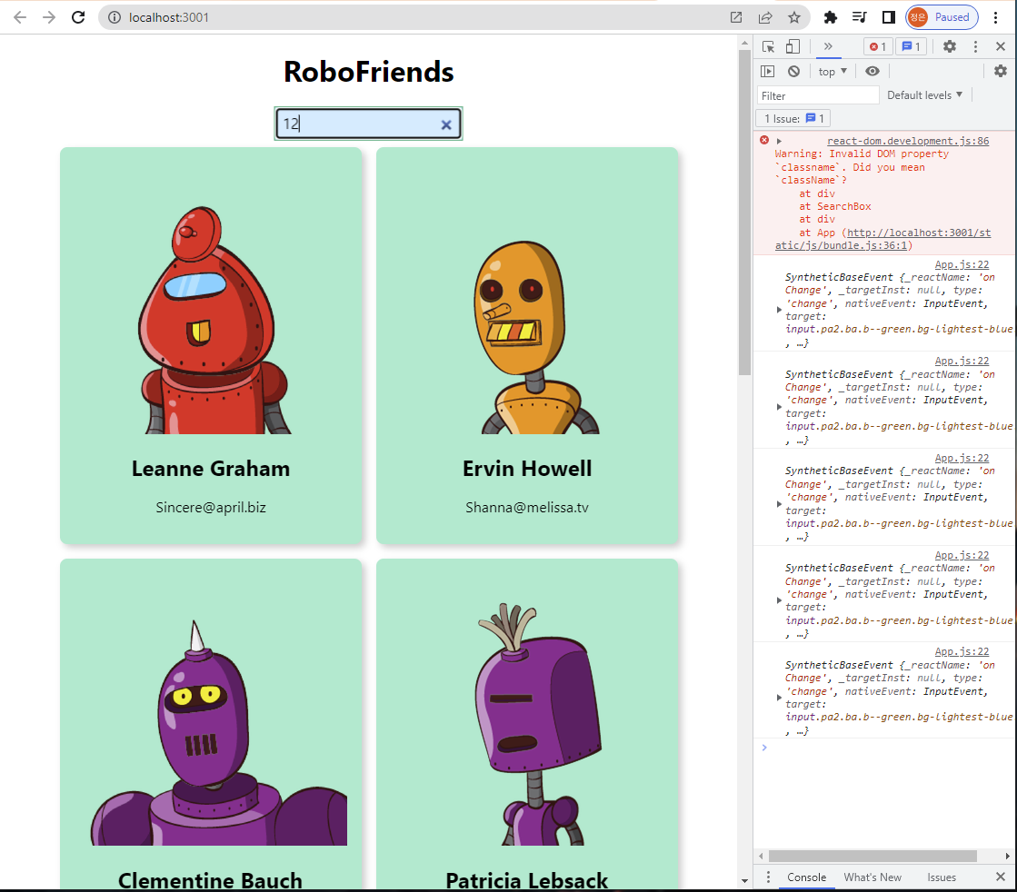

**To Log text onChange in**

<SearchBox /> using func

onSearchChange() {

console.log(event.target.value)

}

in App.js:

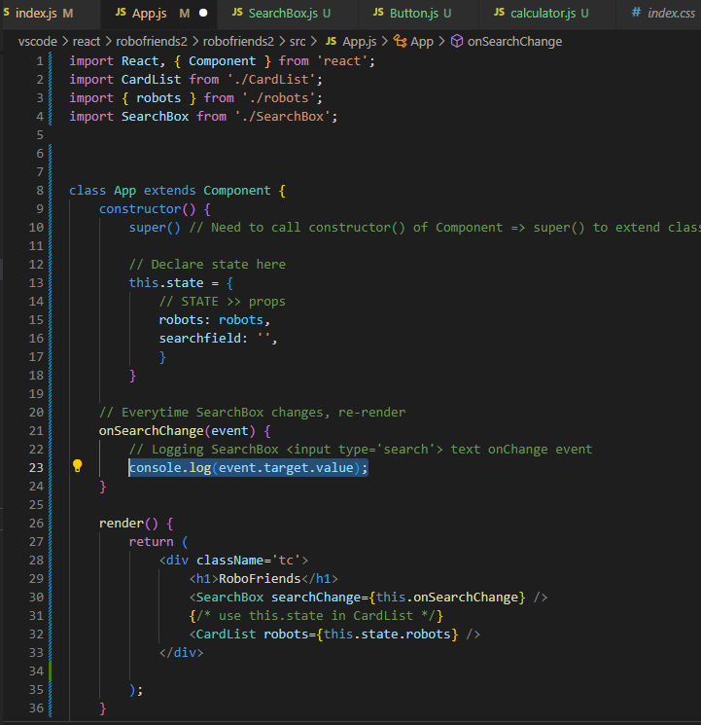

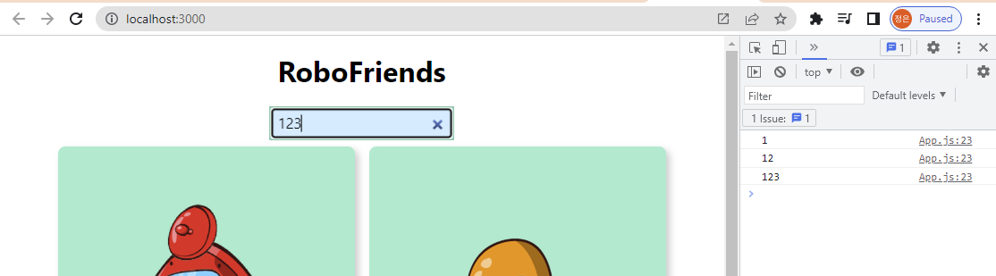

**Data flow:**

**1. In SearchBox.js**

**<SearcBox /> <input> receives users' text input**

**2. <input onChange={searchChange} through props**

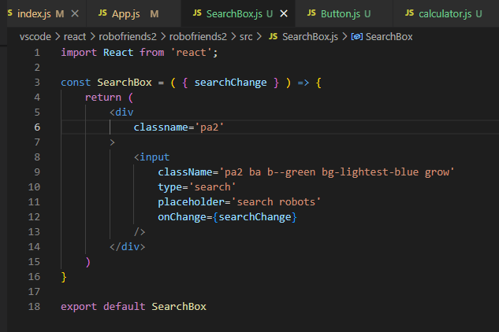

**3. Data in SearchBox.js are passed as props {searchChange} To App.js: <SearchBox searchChange={this.onSearchChange}**

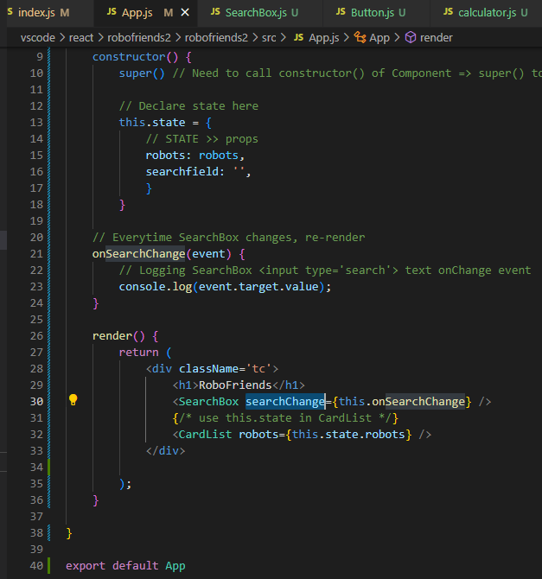

**4. In App.js - render() {...**

**<SearchBox searchChange={this.onSearchChange}**

**// that Logs <input> onChange events using STATE**

**5. Now onSearchChange(event) { console.log(event.target.value); } runs**

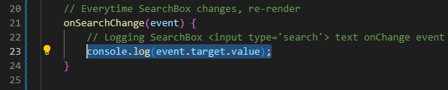

**Now create a filter function in onSearchChange(event) { } to filter robots:**

const filteredRobots = this.state.robots.filter(robot => {

return

robot.name.toLowerCase().includes( this.state.searchfield.toLowerCase() )

})

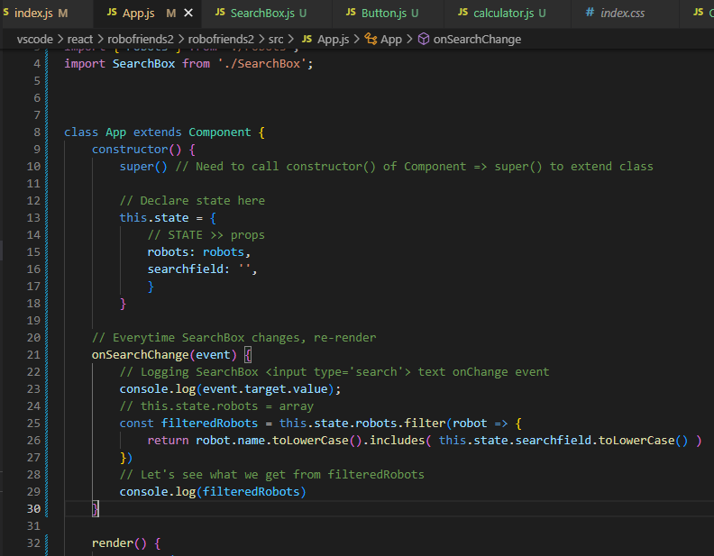

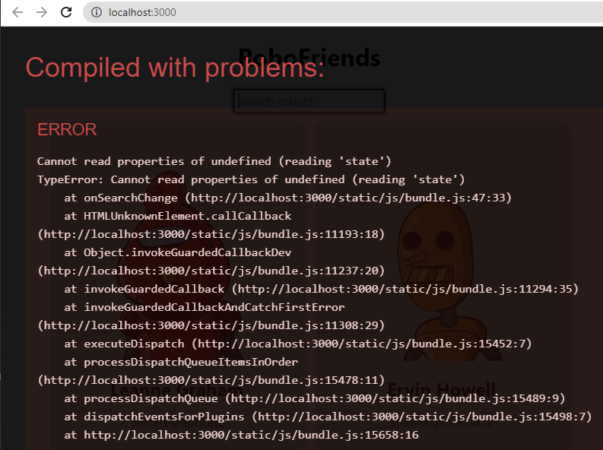

*****

Need to change **onSearchChange(event) { }** in App.js to an Arrow function to get it working.

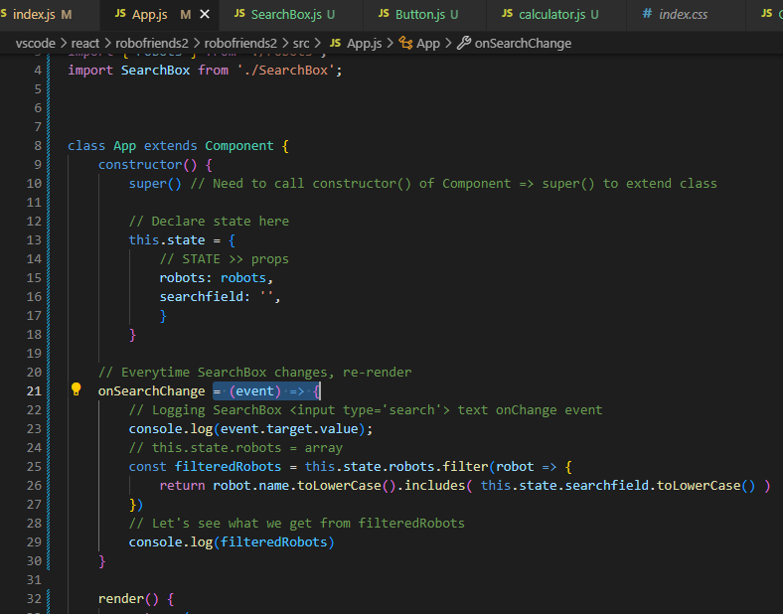

As { searchChange } props in SearchBox.js is receiving text changes as an onChange event that should only be **triggered upon users' text input**

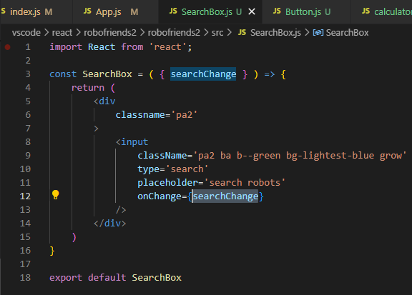

Go to rendered React app:

typing robots name in searchfield still returns all 10 robots

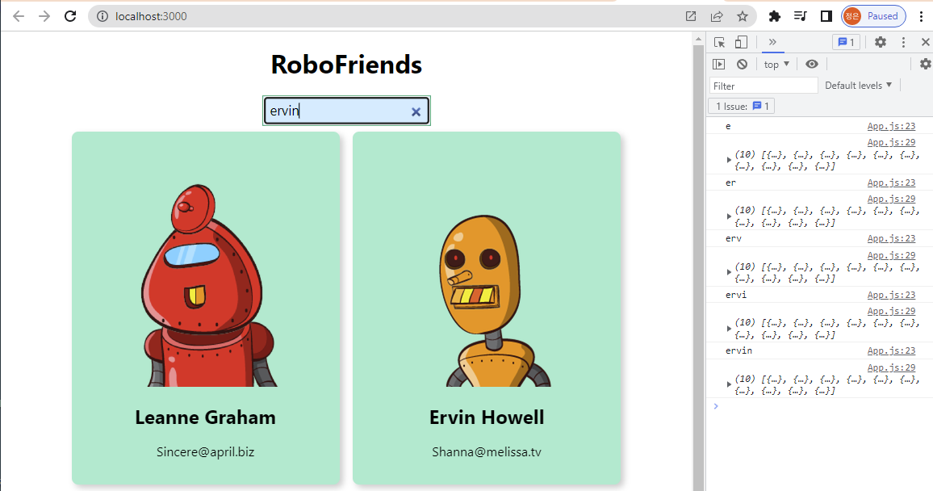

We need onSearchChange = (event) => { } to accept text onChange using **this.setState( { } )**

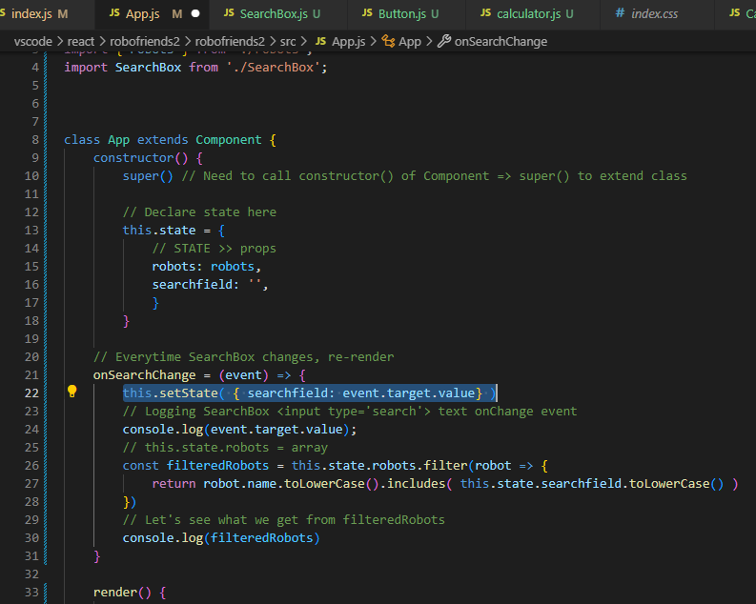

Now robots are getting filtered in <SearchBox />,

yet NOT on render() { }

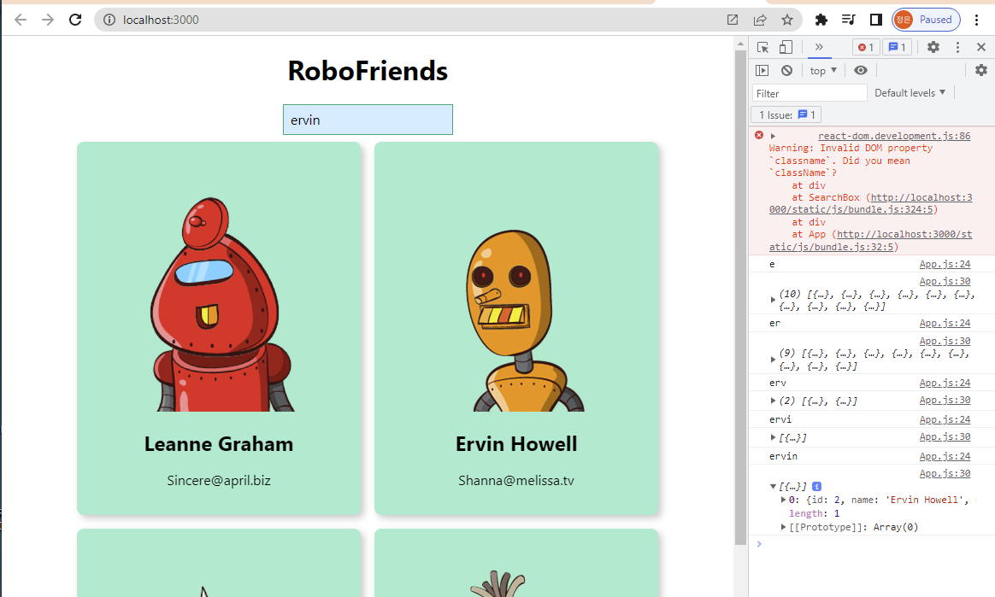

Now, in App.js:

We need to get <SearchBox /> communicating with filteredRobots in render() { <CardList /> }

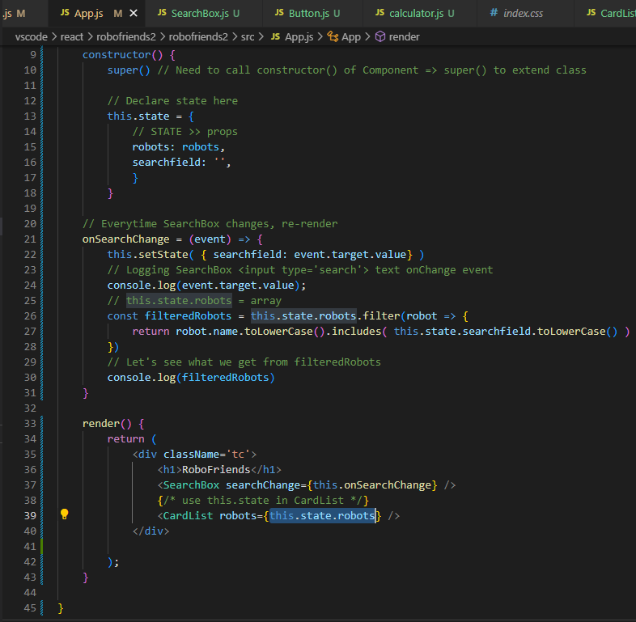

by **moving const filteredRobots** in onSearchChange = (event) => { } **to render() { }**

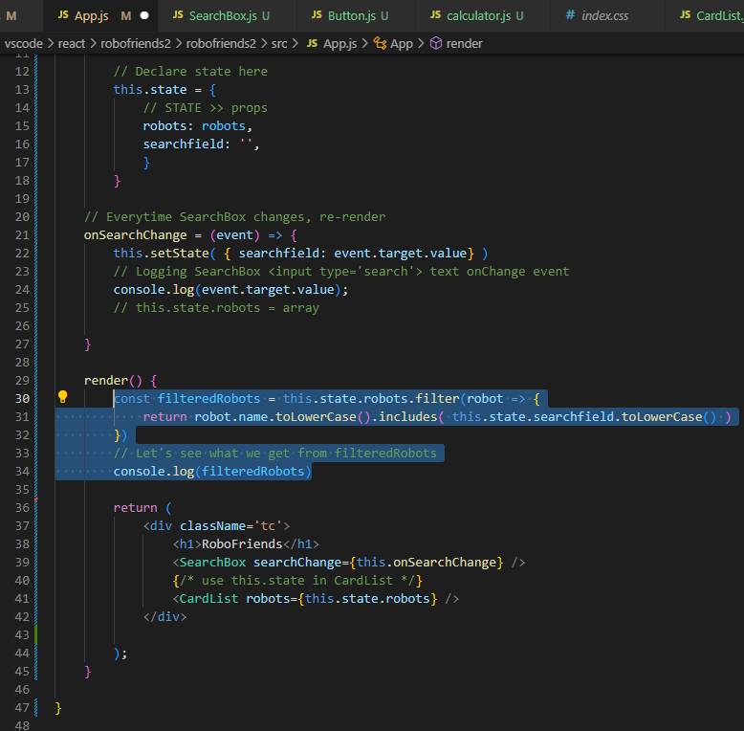

**To re-render <CardList /> upon**

**text onChange in <SearchBox /> & updating <CardList />**

**Now change:**

render() {

const filteredRobots = ...

console.log(filteredRobots)

return (

<div className='tc'>

<h1>RoboFriends</h1>

<SearchBox searchChange={this.onSearchChange} />

**<CardList robots={filteredRobots} />**

</div>

);

}

}

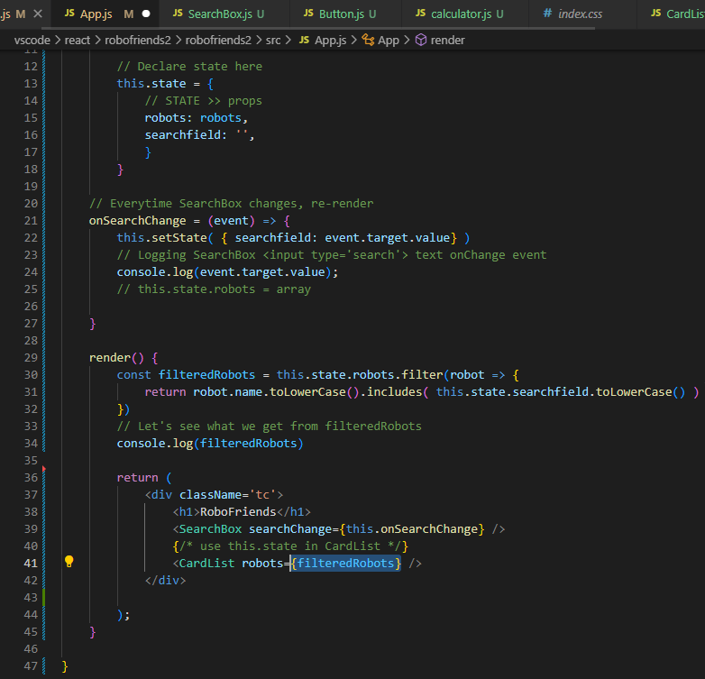

**Now,**

**<App /> is re-rendering <CardList /> upon text changes in <SearchBox />**

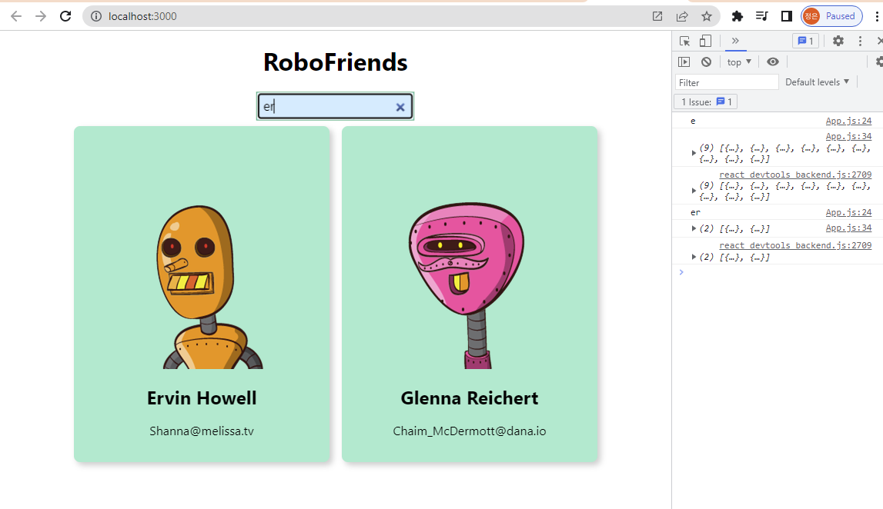

Styling in React - reading

Friday, April 28, 2023

11:45 AM

Sega Logo Font

<https://www.cufonfonts.com/font/sega-logo-font>



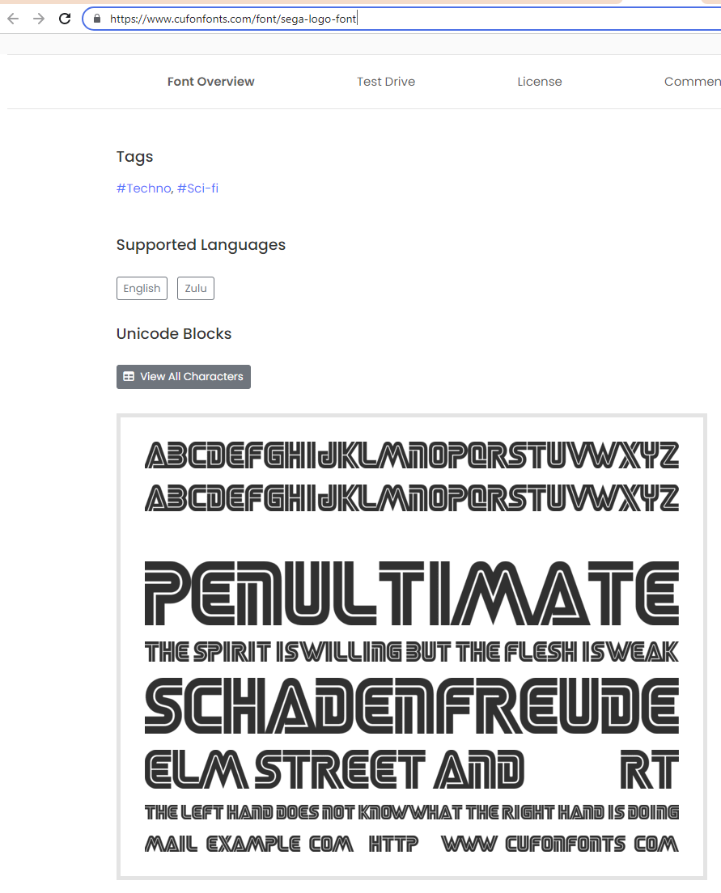

Font Face - CSS styling independent to users' system package

<https://css-tricks.com/snippets/css/using-font-face-in-css/>

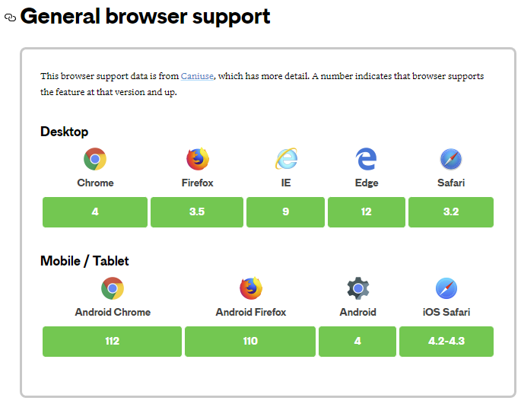

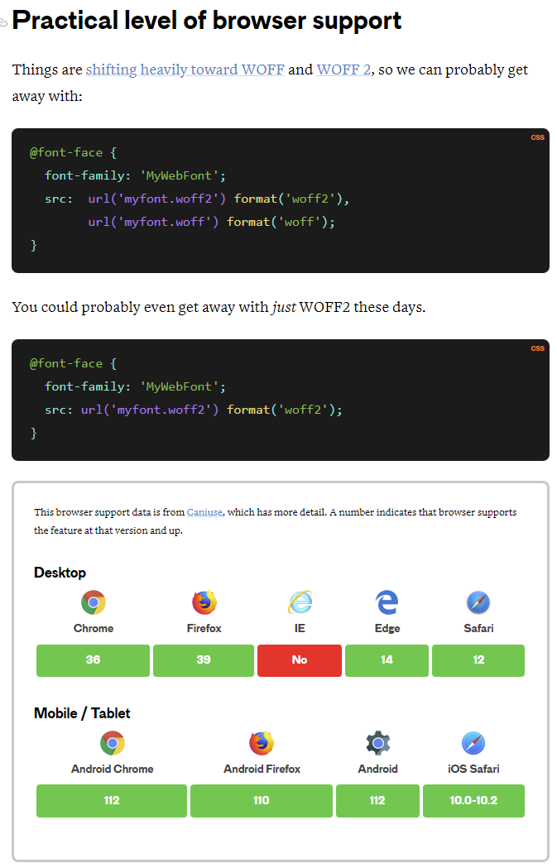

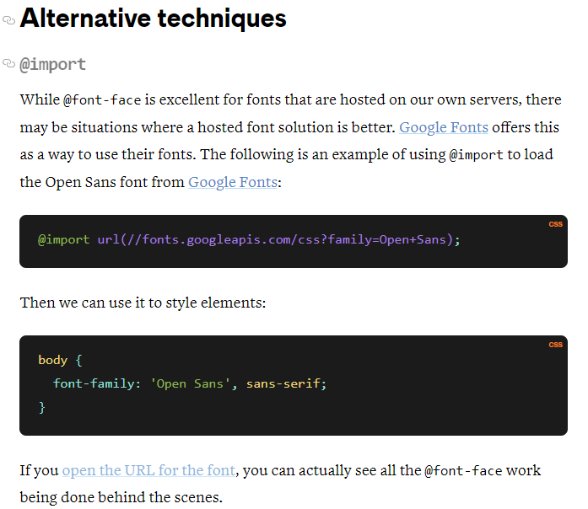

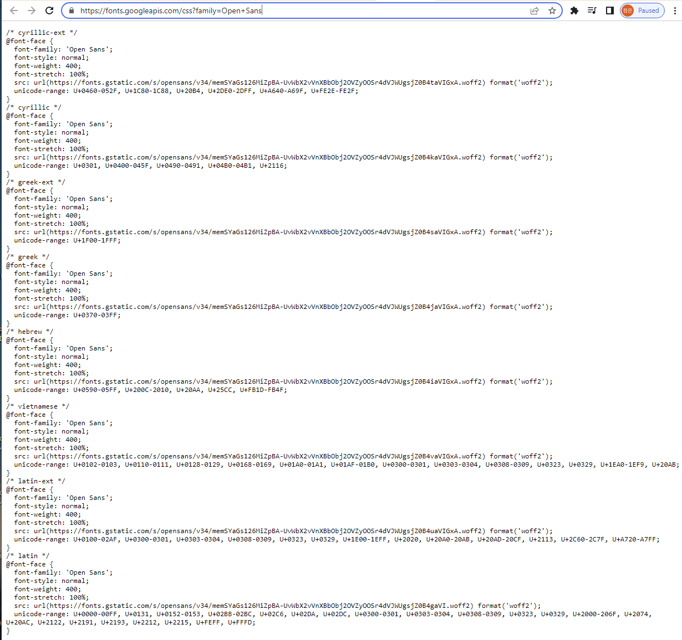

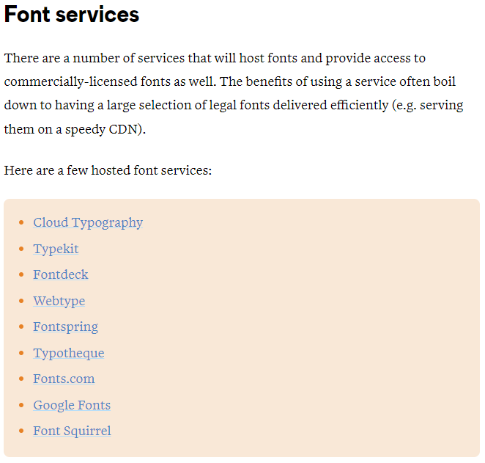

Font Face rules:

<https://w3c.github.io/csswg-drafts/css-fonts-4/#font-face-rule>

Styling React App

Friday, April 28, 2023

11:53 AM

Go to index.css:

body {

}

insert:

background: linear-gradient(...

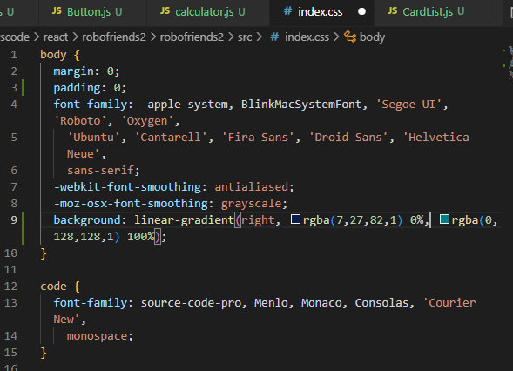

to left

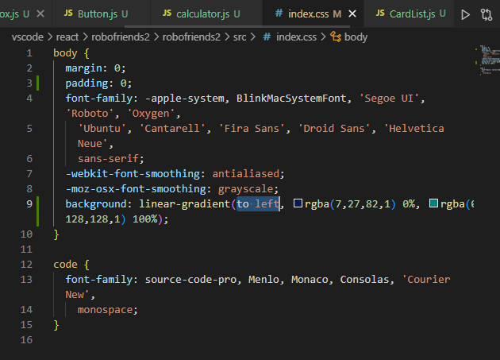

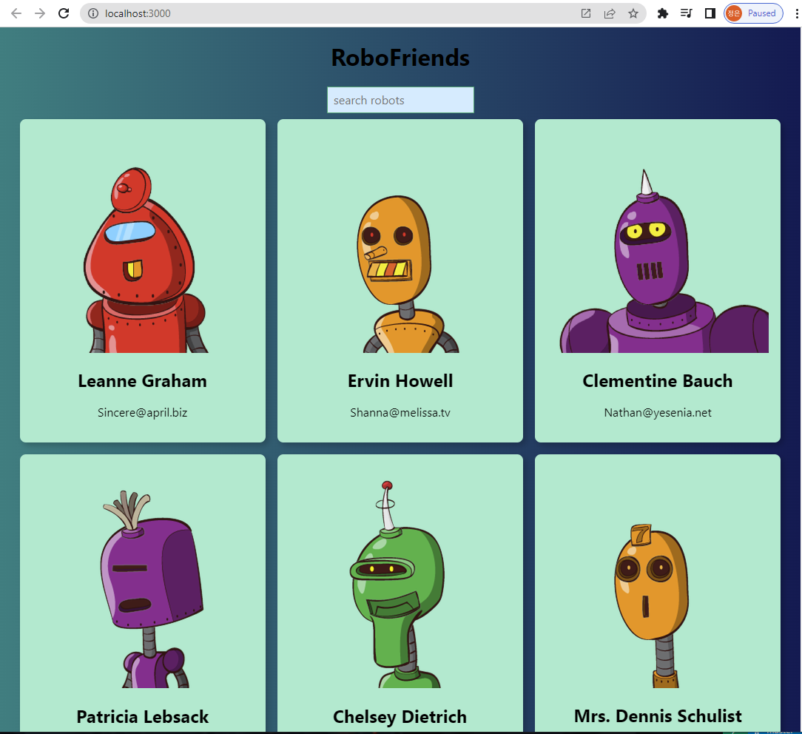

We use Sega Font Face:

<https://www.cufonfonts.com/font/sega-logo-font#google_vignette>

Download -> style.css -> copy & paste to App.css:

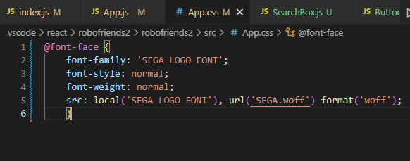

Drag .woff file to vscode/robofriends2/

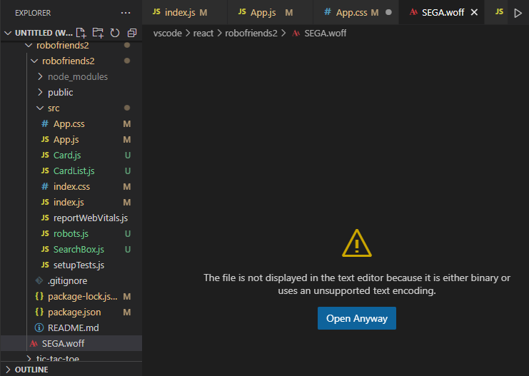

Move .woff to robofriends/src

App.js -> import './App.css';

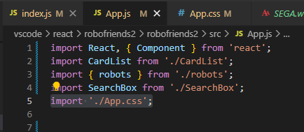

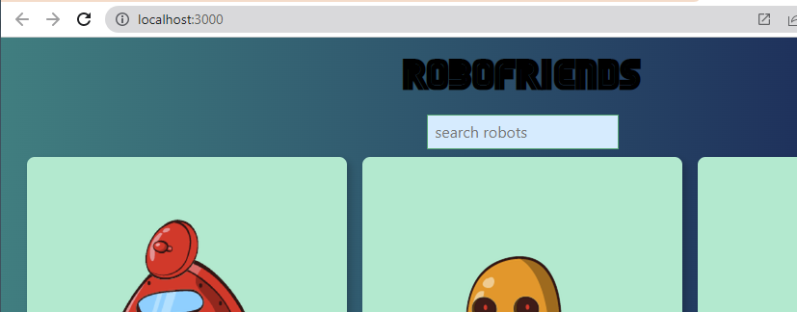

App.css:

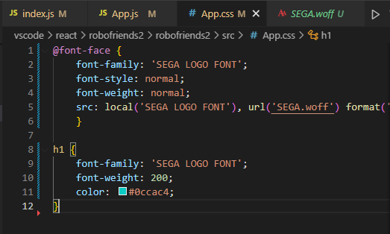

We can also do inline styling in App.js thanks to import 'tachyons'; :

<h1 className='f1' >RoboFriends</h1>

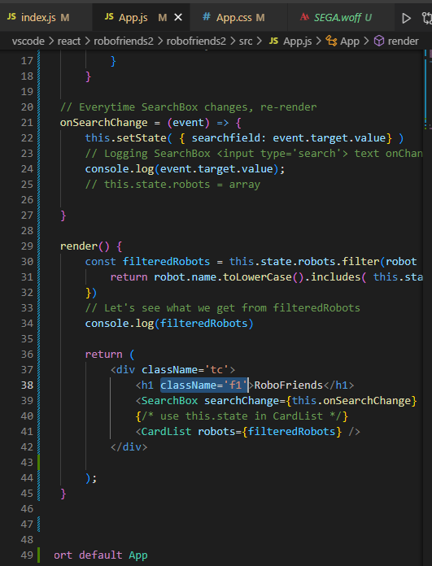

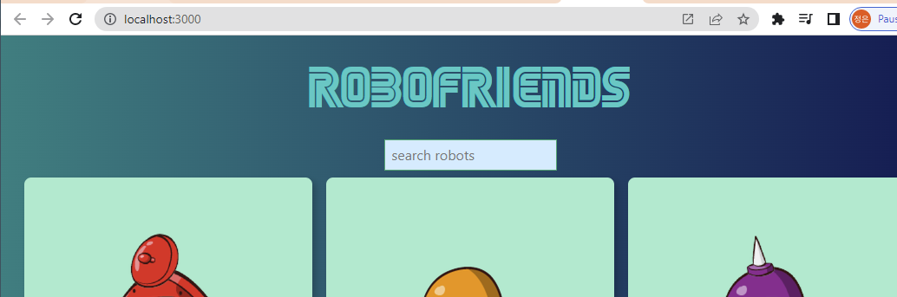

React Life-cycle Hooks

Friday, April 28, 2023

1:18 PM

In real world, robots data would not exist as those in robots.js

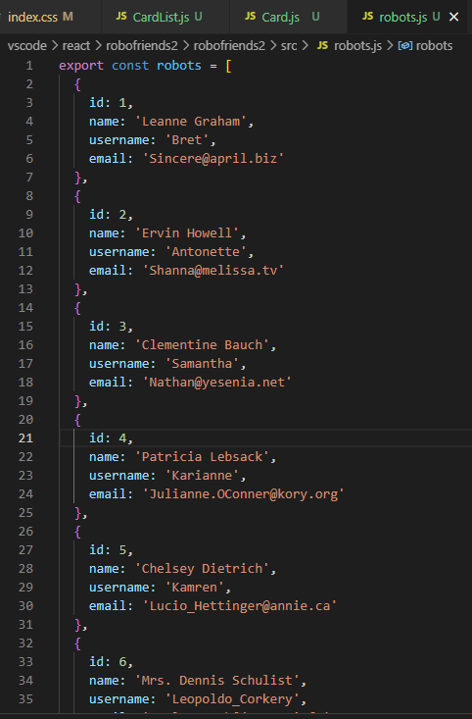

Data might be coming from APIs:

JSON Placeholder

<https://jsonplaceholder.typicode.com/>

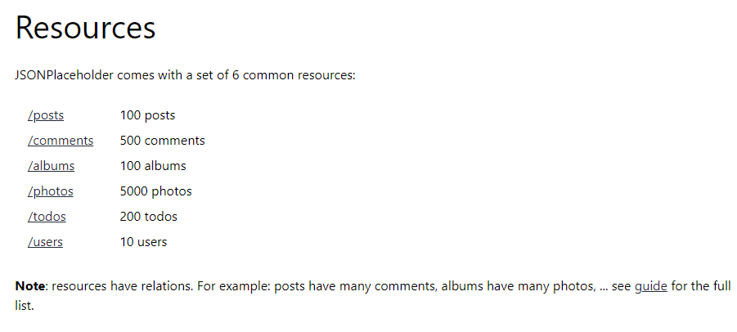

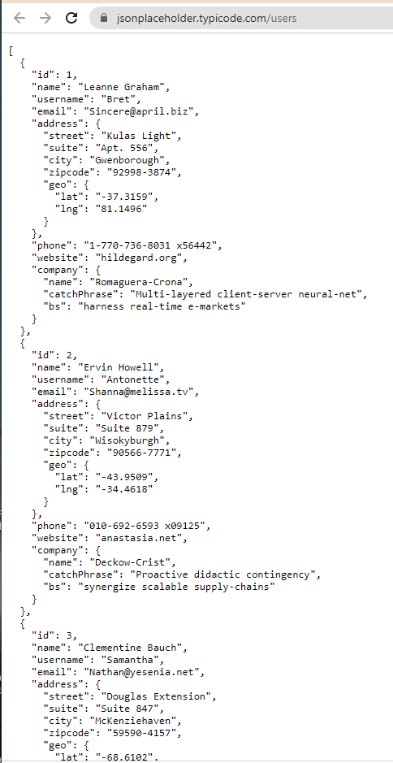

Go to App.js:

**In reality, robots will be an empty array until we open our app, then our app requests data from somewhere else over internet.**

this.state = {

robots: [],

searchfield: ''

}

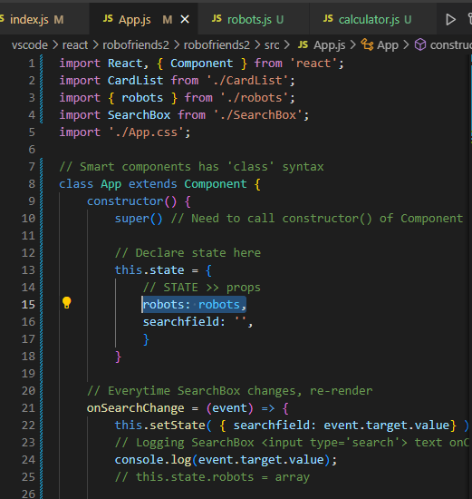

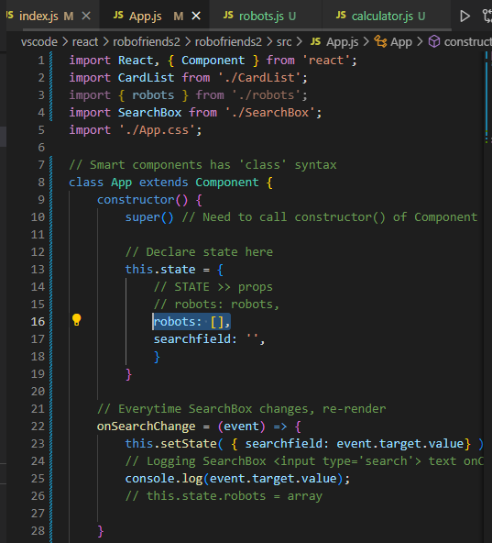

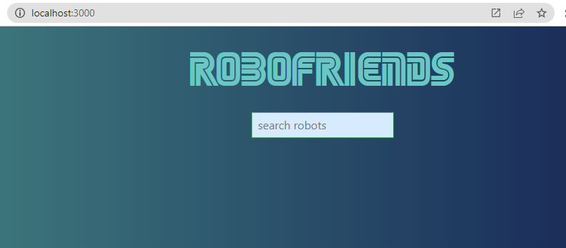

**Lifecycle methods in React**

<https://www.w3schools.com/react/react_lifecycle.asp>

We have 3 sections:

1. Mounting

2. Updating

3. Unmounting

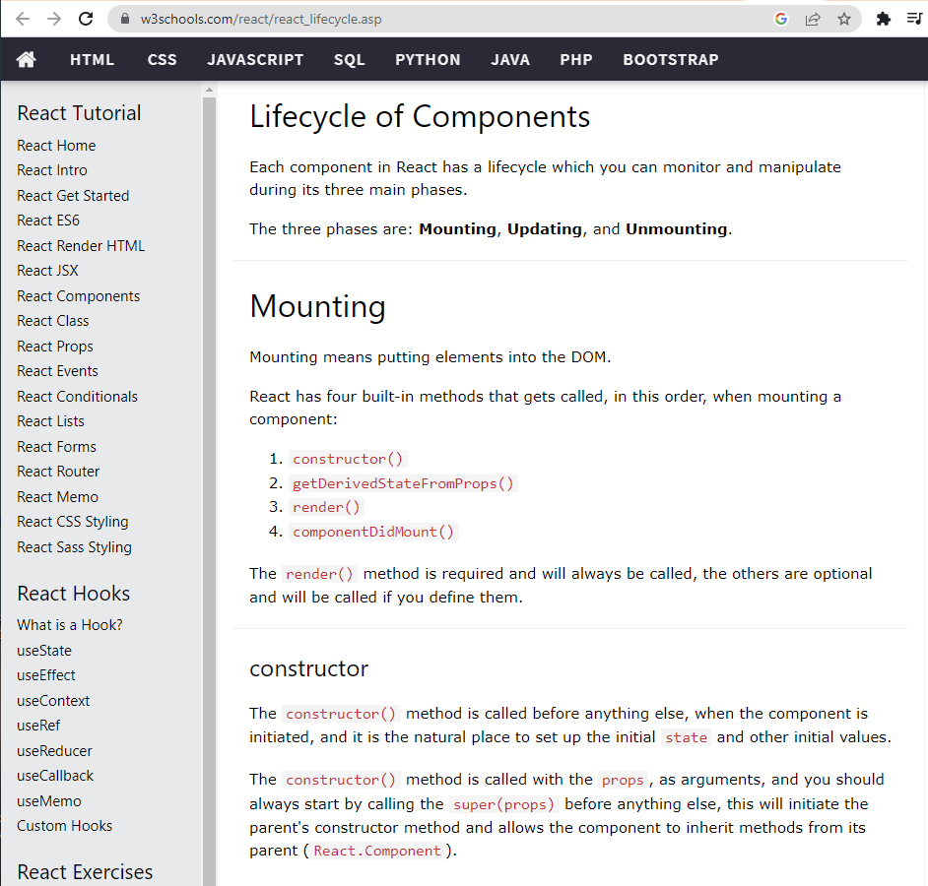

Mounting is done in src/index.js:

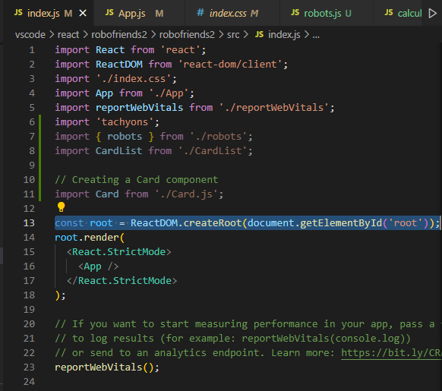

&&

public/index.html:

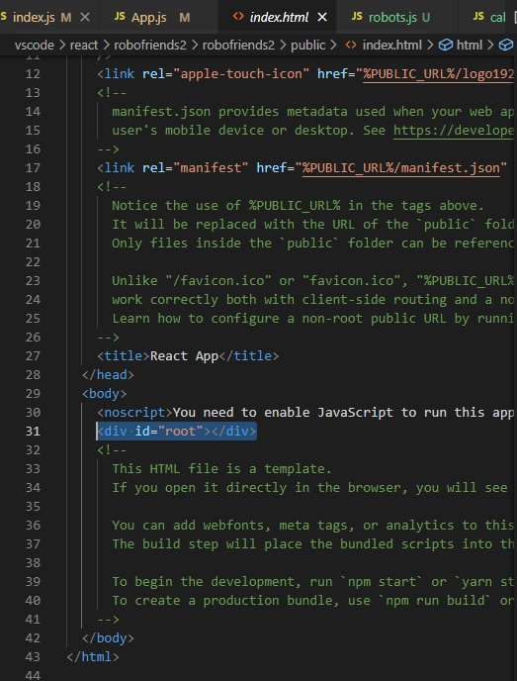

When mounting (starting our app),

these lifecycle hooks get hit in sequence:

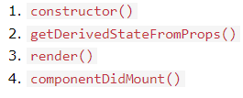

1. constructor()

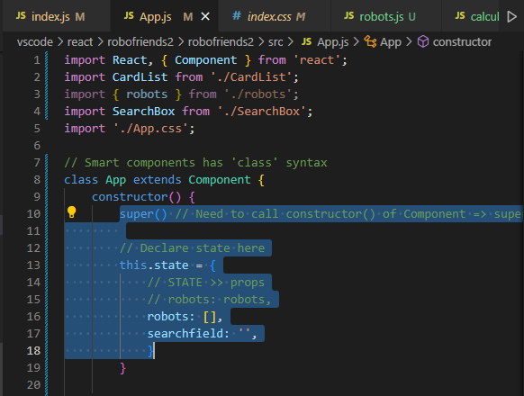

2. getDerivedStateFromProps() OR componentWillMount()

None -> Skip

3. render()

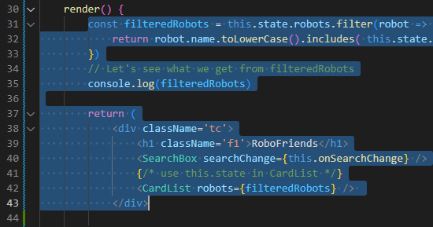

4. componentDidMount()

None -> skip

**Updating:**

In our app, everytime we type something in <SearchBox />

App gets re-rendered, as functions receive new inputs.

**Unmounting:**

When a component is removed from a page

====

We wanna try out componentDidMount() after render() in App.js:

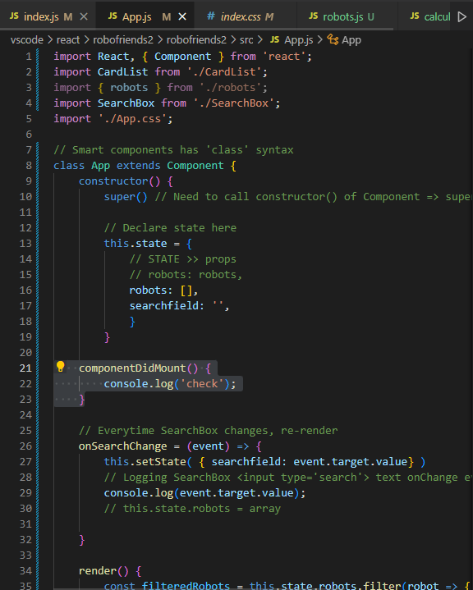

launch React app -> F12:

'check' is logged twice because of <StrictMode />

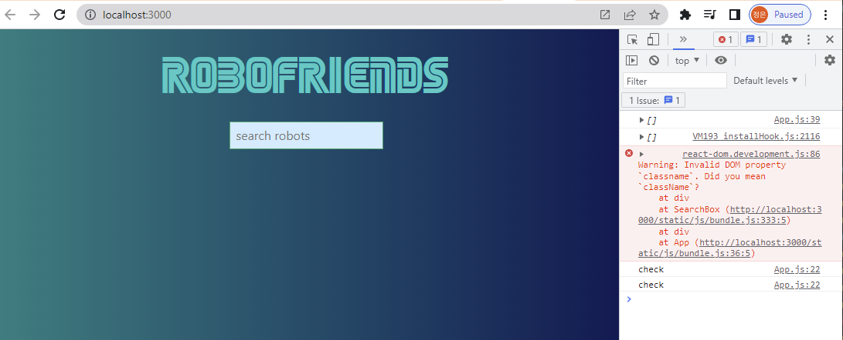

**Putting back to robots in App.js from robots.js using:** componentDidMount() {

this.setState( { robots: robots} );

}

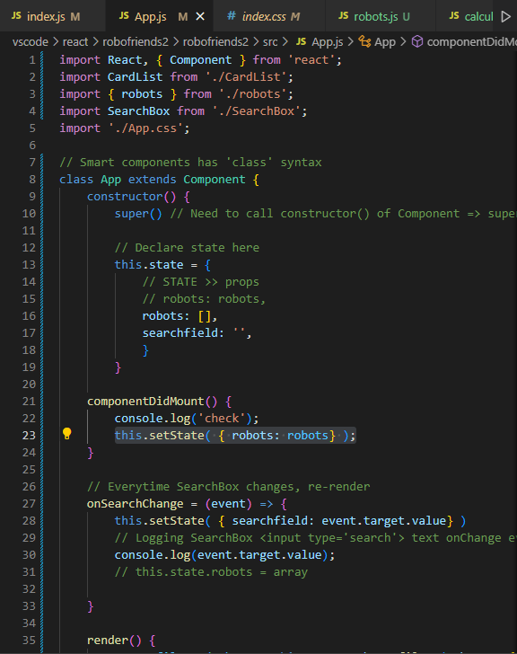

We'll get our robots back:

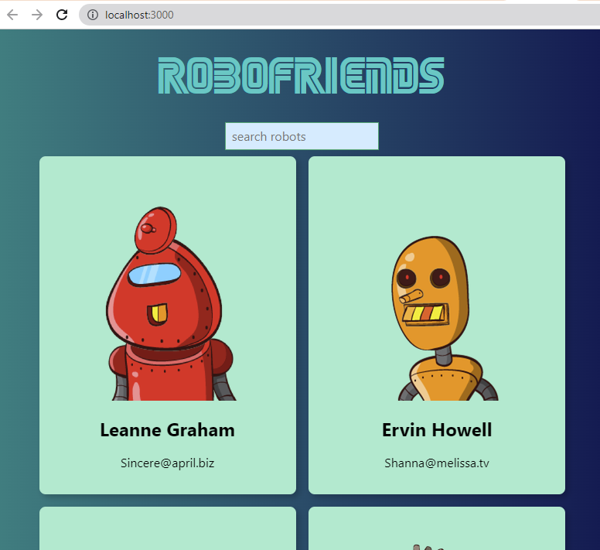

To test the lifecycle method sequence:

We add 3 console.logs to:

1. constructor()

2. componentDidMount()

3. render()

1. constructor()

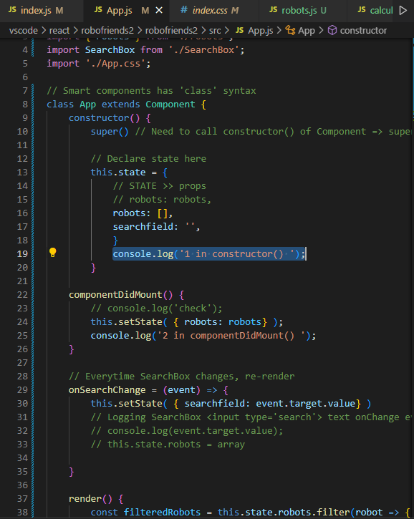

2. componentDidMount()

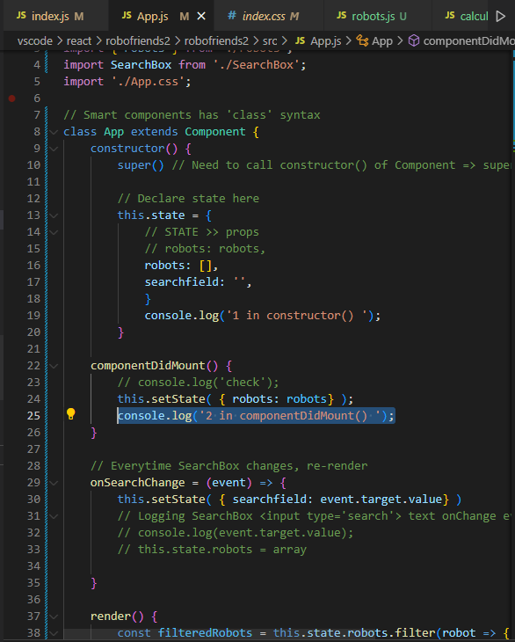

3. render()

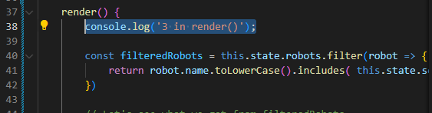

Launch React app -> F12 console to inspect:

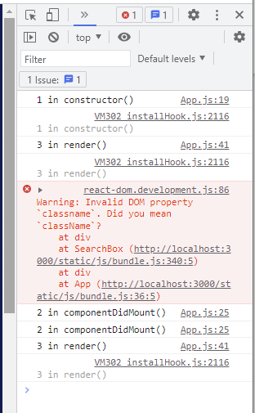

1 constructor() -> 3 render() -> 2 componentDidMount()

2 componentDidMount() detects changes:

this.setState( { robots: robots} );

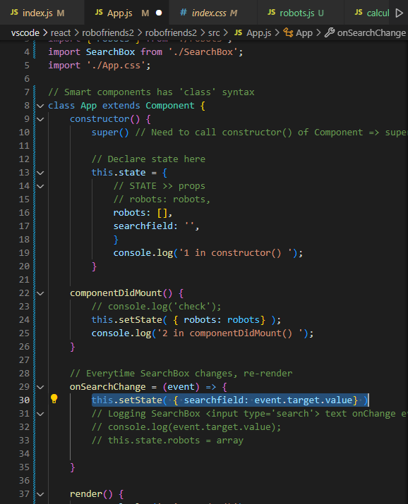

3 render() again

**Fetching users (robots) data from URL**

<https://jsonplaceholder.typicode.com/users>

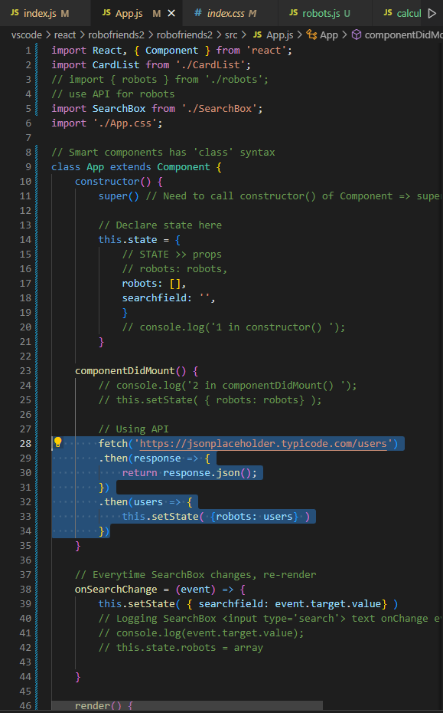

componentDidMount() {

// Here is where STATE sits

// Parsing data from API to this.**setState**

fetch('https://jsonplaceholder.typicode.com/users')

.then(**response** => {

// Convert response to JSON format

return **response**.**json()**;

})

.then(**users** => {

this.setState( {robots: **users**} )

// We can log data

console.log(users);

})

}

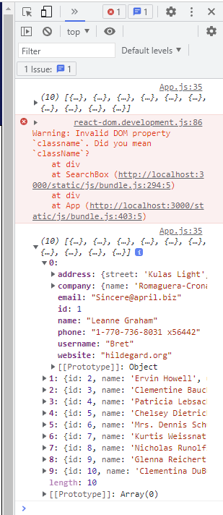

**The little lagging when React app starts is due to data fetching from API

====

is fetch a window object?

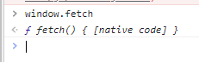

Yes

fetch comes with all browsers now, a tool for us to make requests to servers:

URL below is from a web server

<https://jsonplaceholder.typicode.com/users>

**if API fetching takes too long**

**we can do an if statement in render() { }**

**[P.S Please do NOT put Loops into render()**

**This act is gonna screw everything up...]**

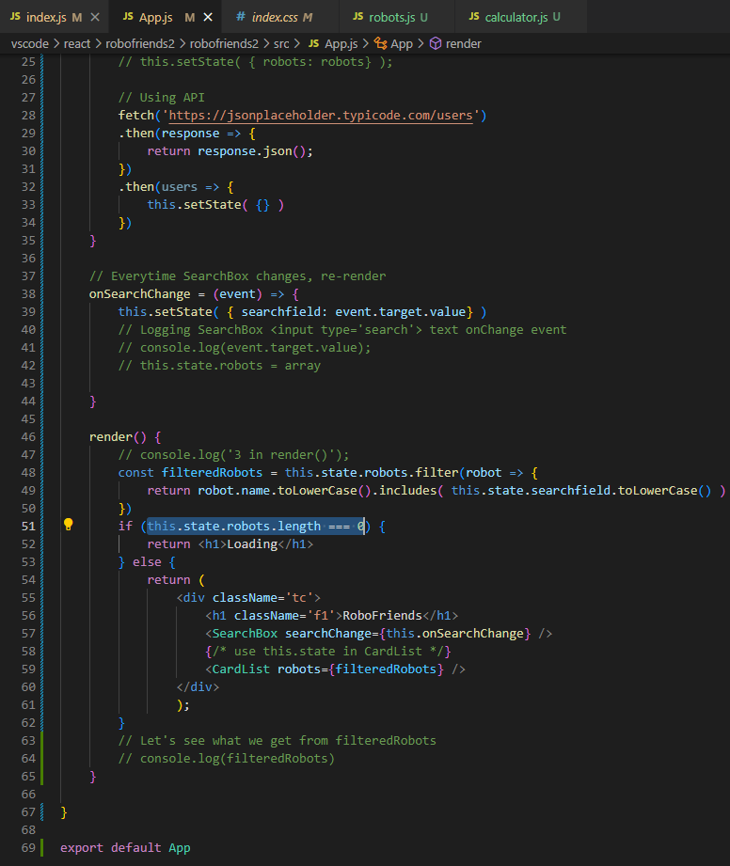

Now **test** render() { } Loading when { robots: users } are **NOT fetched** to **this.setState** in 2nd render

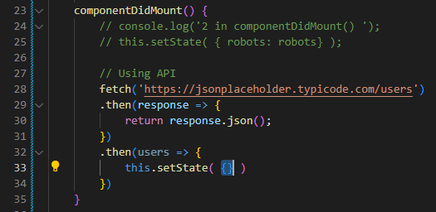

**render() {**

**const filteredRobots = this.state.robots.filter(robot => {**

**return robot.name.toLowerCase().includes( this.state.searchfield.toLowerCase()**

**})**

**if (this.state.robots.length === 0) {**

**return <h1>Loading</h1>**

**} else {**

**return (**

**<div>**

**<h1>RoboFriends</h1>**

**<SearchBox searchChange={this.onSearchChange} />**

**<CardList robots={filteredRobots} />**

**</div>**

**);**

**}**

**}**

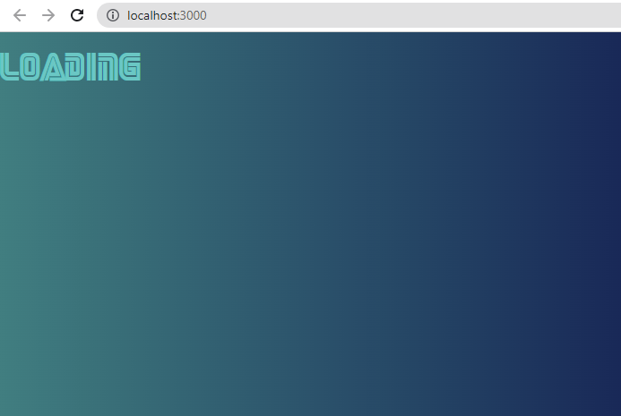

=====**Building React app5**

Just wanna Pin <SearchBox /> when scrolling down along the page

Maybe we can create a new <Scroll /> component to wrap <CardList />:

<Scroll>

{ children } <CardList />

</Scroll>

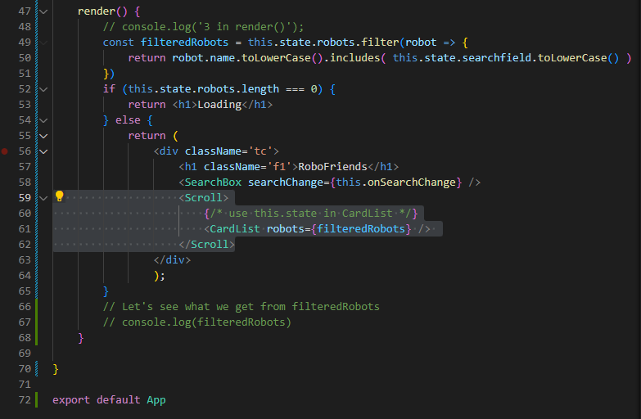

Testing { children } props in Scroll.js:

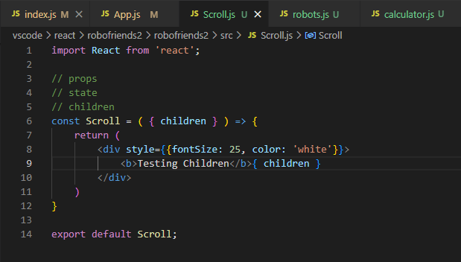

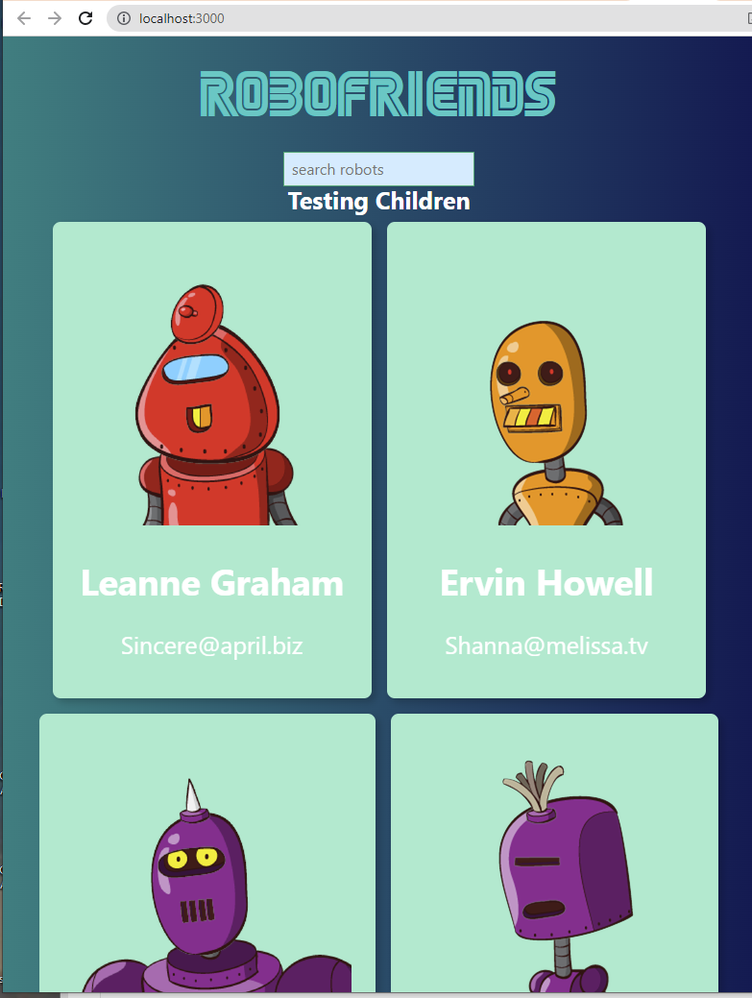

Thus, <Scroll> is now wrapping <CardList />

Add styling:

overfloxY: 'scroll',

height: '1000px',

to make <CardList /> scrollable

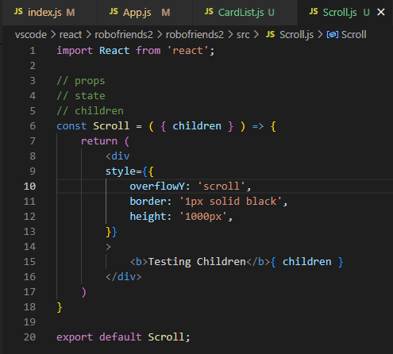

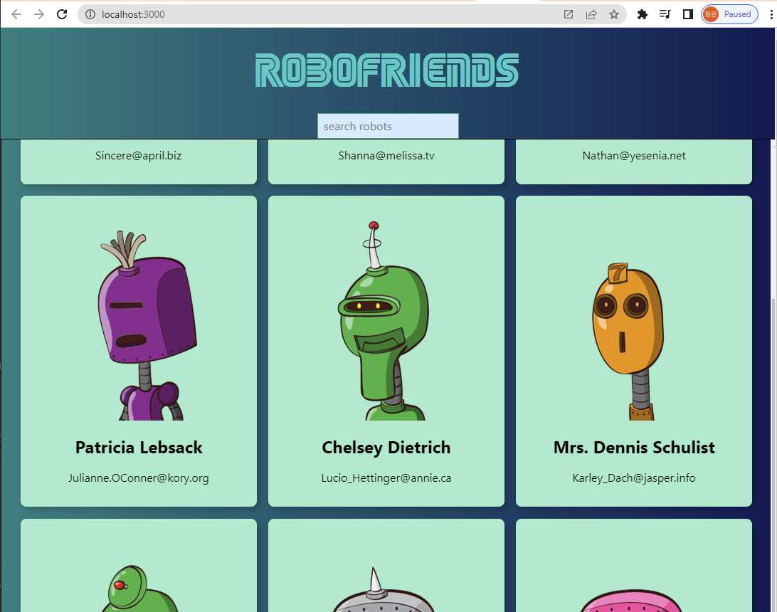

**Building React app6**

**Folder structuring:**

**Make App most extensible & cleaner for team corp**

1. create src/**components**

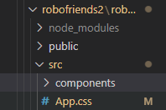

to store components.js

i.e.

**CardList.js**

**SearchBox.js**

**Scroll.js**

2. create src/**containers**

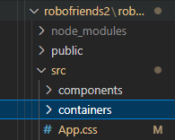

to store smart components with:

**STATEs**

**Lifecycle hooks**

**Class**

lifecycle hooks - class - constructor() { }

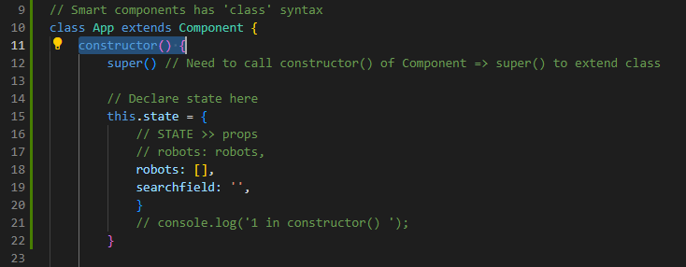

lifecycle hooks - componentDidMount() { }

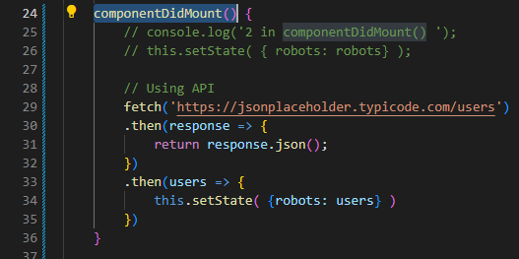

lifecycle hooks - render() { }

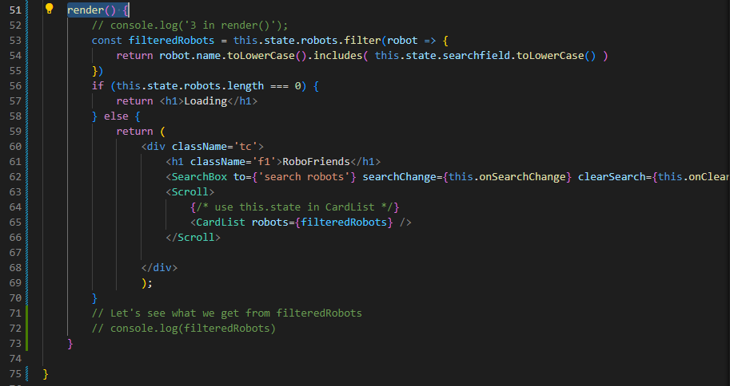

----

cd vscode/react/robofriends

// Move App.css to containers:

mv ./App.css src/containers/App.css

// Move App.js to containers:

mv ./App.js ./containers/App.js

For SearchBox.js, Scroll.js, CardList.js, Card.js:

mv ./Card.js ./components/Card.js && mv ./CardList.js ./components/CardList.js && mv ./Scroll.js ./components/Scroll.js && mv ./SearchBox.js ./components/SearchBox.js

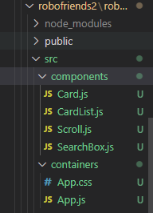

Font file .woff used by App.css:

mv ./SEGA.woff ./containers/SEGA.woff

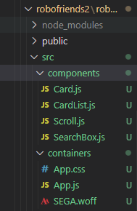

Now, let's fix the paths for App.js:

import CardList from '../components/CardList';

import SearchBox from '../components/SearchBox';

import Scroll from '../components/Scroll';

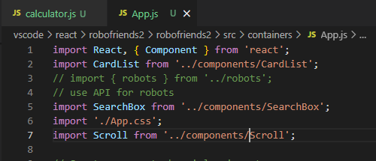

Now fix path for index.js:

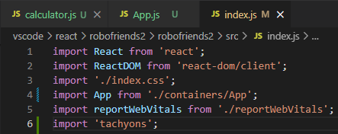

====Using Babel to build an optimized app

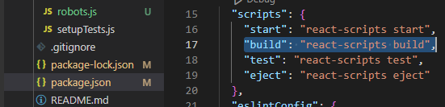

npm run build

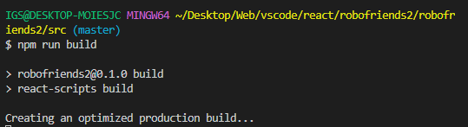

Browse build folder:

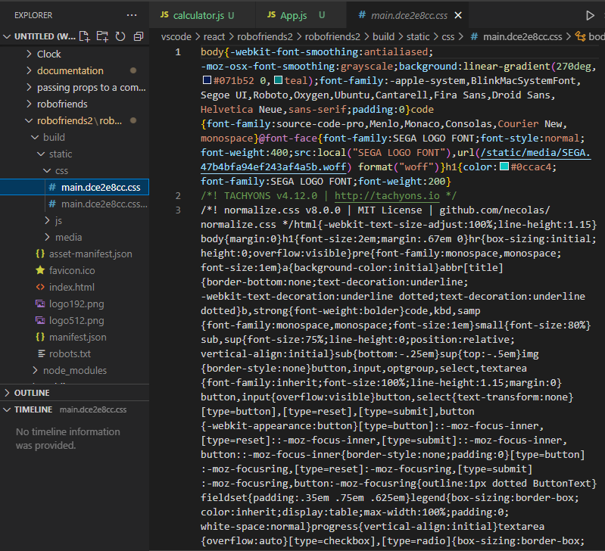

Now, can deploy our app using build folder to anywhere on the internet

Keeping your React project updated

Now React has ver. 18.2:

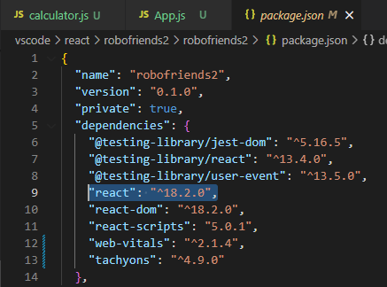

Download an older ver. of RoboFriends from ZTM:

<https://github.com/aneagoie/robofriends.git>

git clone <https://github.com/aneagoie/robofriends.git~>

// Test github project:

npm start

// Fix vulnerability & critical issues

npm audit fix

// Run 1 by 1 for issues to avoid breaking downloaded App

npm audit

// To update dependencies

npm update

"react": "^18.2.0", => update up to 18.x.x

"react": ">18.2.0", => update can > 18.x.x

"react": "^18.^2.0", => update up to 18.2.x

// Assume everything updated & works

npm audit fix --force

i.e. When react 17.x.x comes out => edit it

"react": "^17.>0.0",

// Check issues again

npm audit

// After fixing

git add .

git commit -m"fixing security issues"

git push origin master

**\*\*\* Simply update package.json file**

Error boundary in React

Saturday, April 29, 2023

5:47 PM

Local folder:



In React v16 -> Error boundary:

touch robofriends2/src/components/ErrorBoundary.js

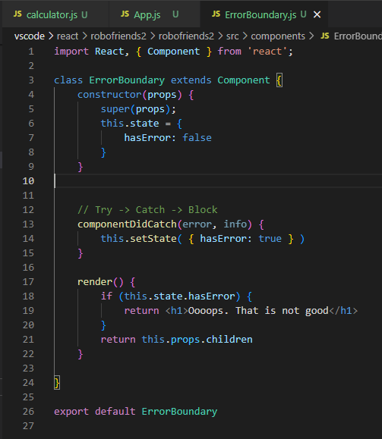

Go to App.js:

import ErrorBoundary from '../components/ErrorBoundary';

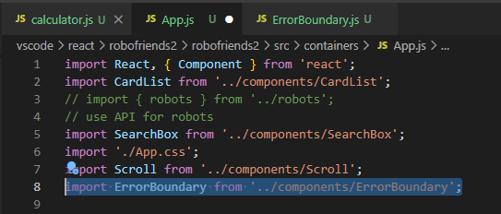

Let's use ErrorBoundary for <CardList />

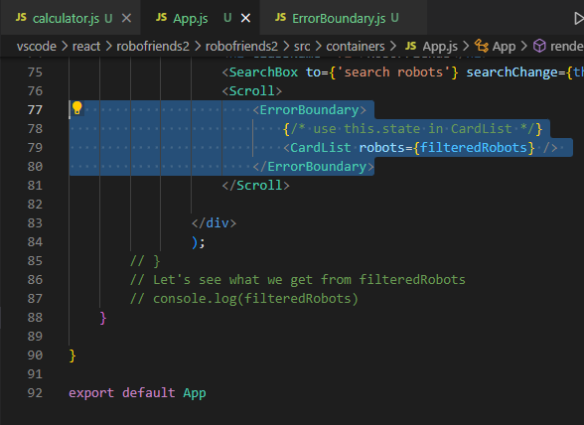

Go to CardList.js:

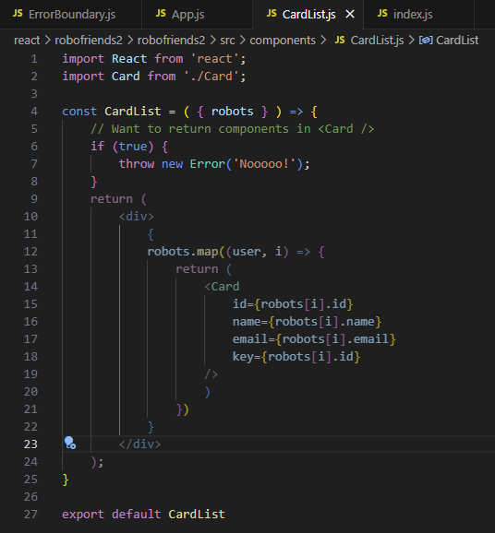

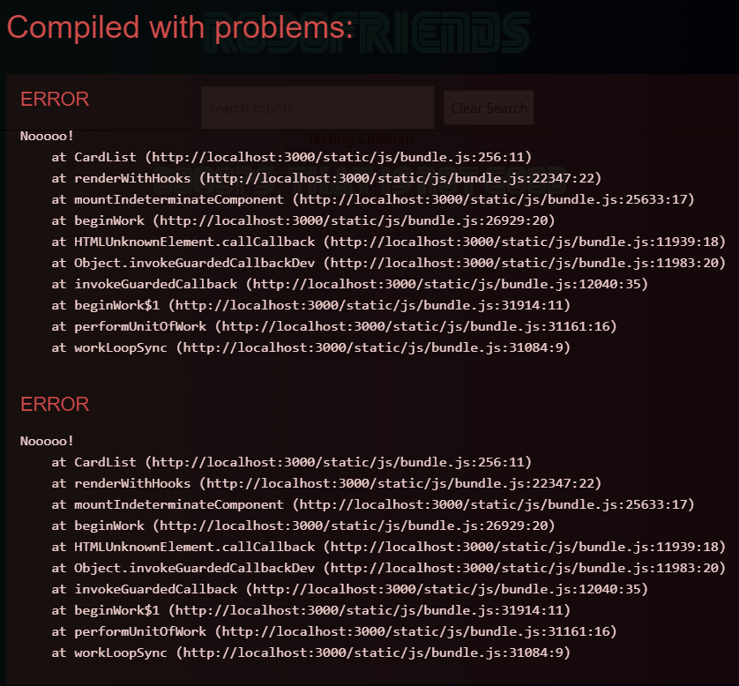

Users now can see Errors in Production env:

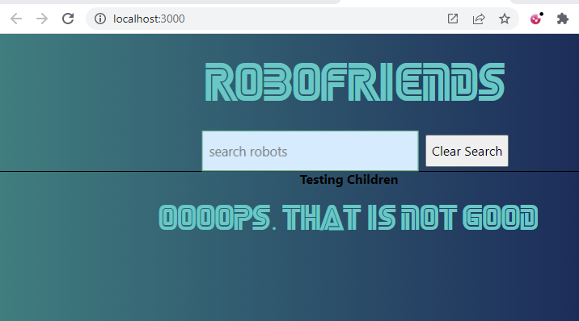

Deploying our React App

1. Create a Github repo:

Your Github account -> Repositories -> **New**

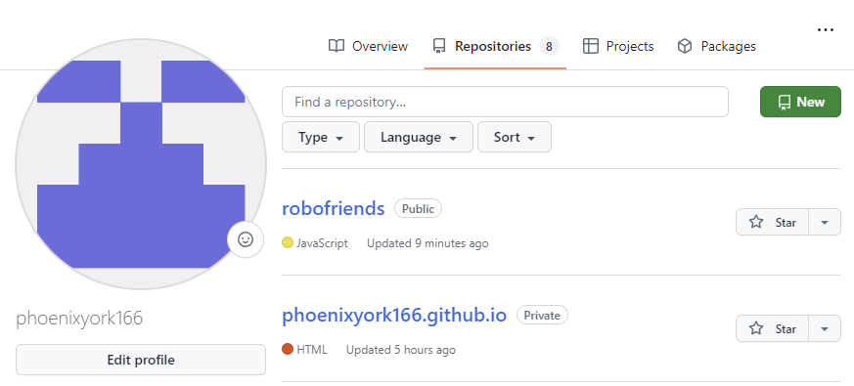

2. Create a new Repository -> bottom right -> click '**Create repository**':

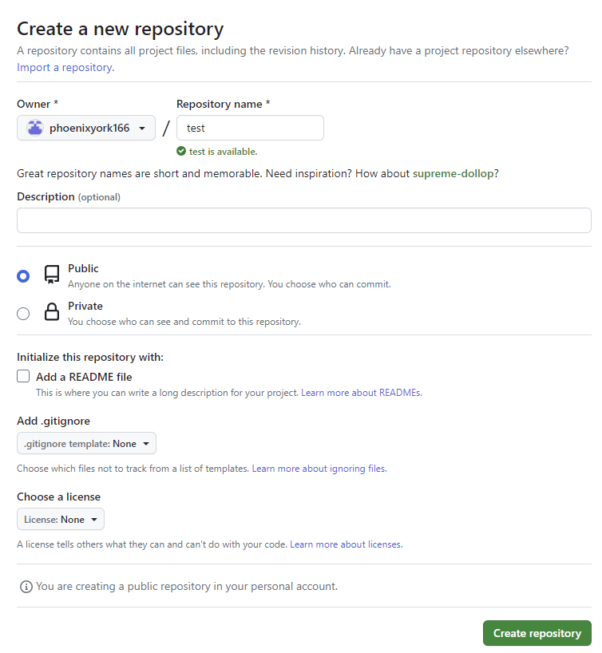

3. Create a new file in the new Repo: username/newRepo by clicking:

Get started by creating a new file

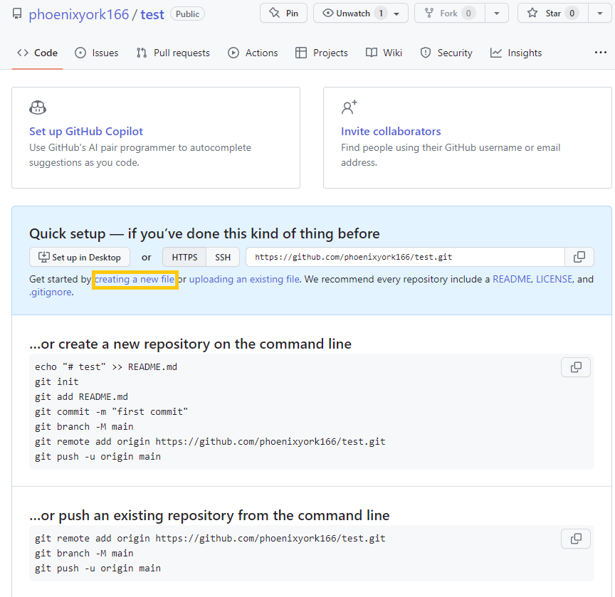

4. Create a README.md -> # your message -> Commit changes

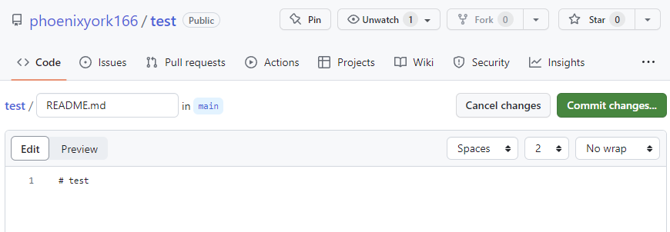

5. Commit changes again:

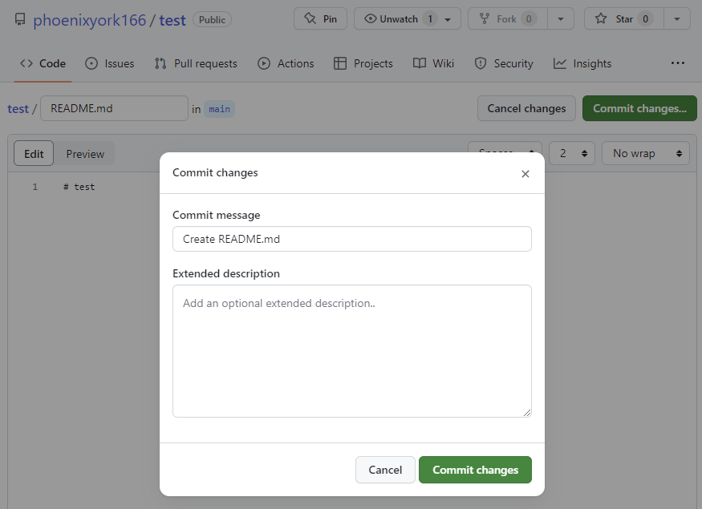

6. This will give you a blank repo with README.md

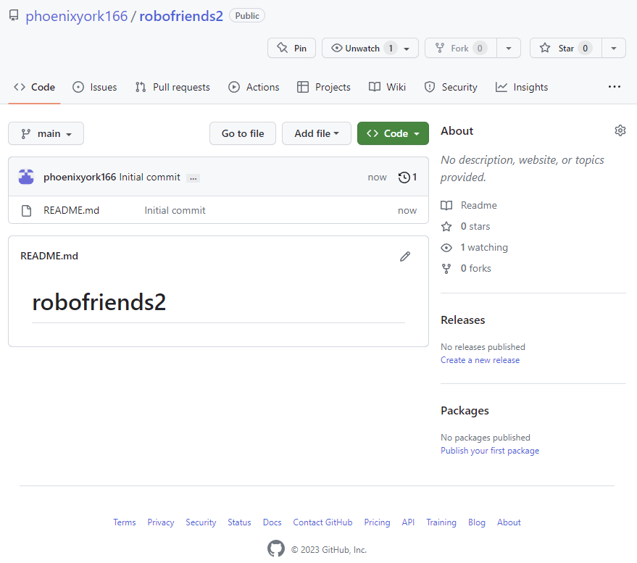

7. Github repo -> Click Code -> HTTPS -> Copy URL:

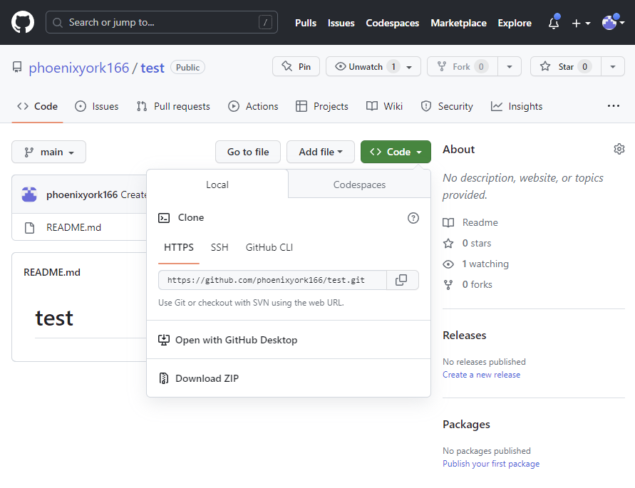

8. Go to vscode -> ./vscode -> git clone Code URL:

git clone <https://github.com/phoenixyork166/robofriends>

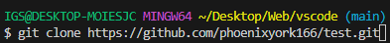

9. git clone <github repo> will create a new local folder in vscode with files:

README.md

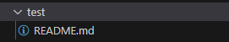

10. Now, right click README.md -> Reveal in File Explorer (Shift+Alt+R):

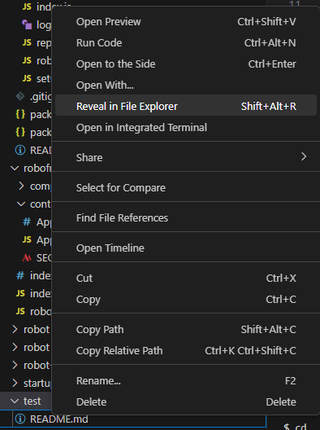

11. the new local folder created by git clone will come up:

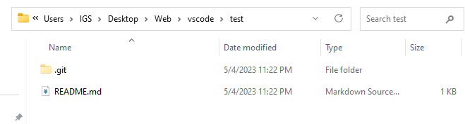

.git file is for git pull, git add, git commit, git push etc.

12. Move all your React App project files to the newly cloned repo:

In my case, vscode\robofriends:

public

src

.gitignore

package.json

package-lock.json

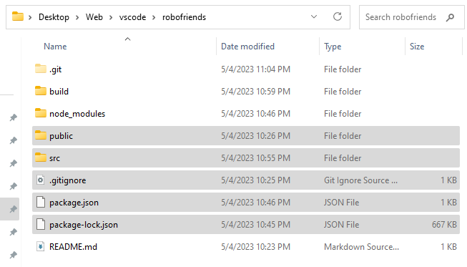

[PS:

If you're building & deploying a React App,

you'll have to git add . -> git commit -m "deploy" -> git push

again after you npm run deploy]

13. Go back to Github -> your new Repo -> Settings:

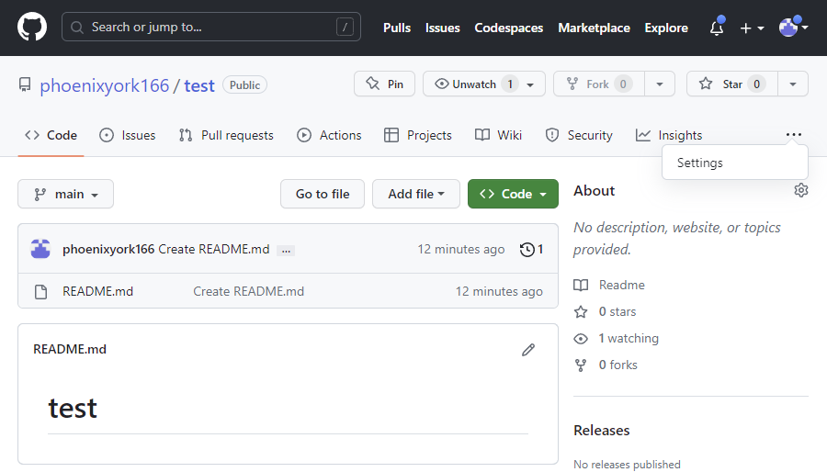

14. Select **Pages** from the left taskbar

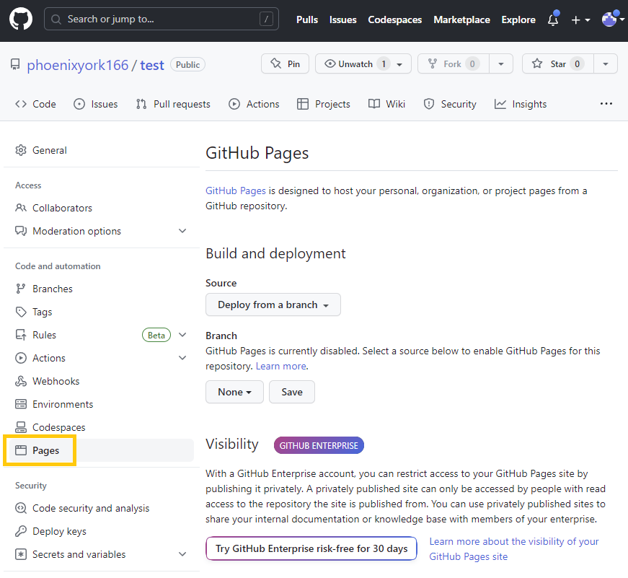

15. Branch -> select 'main' -> Save

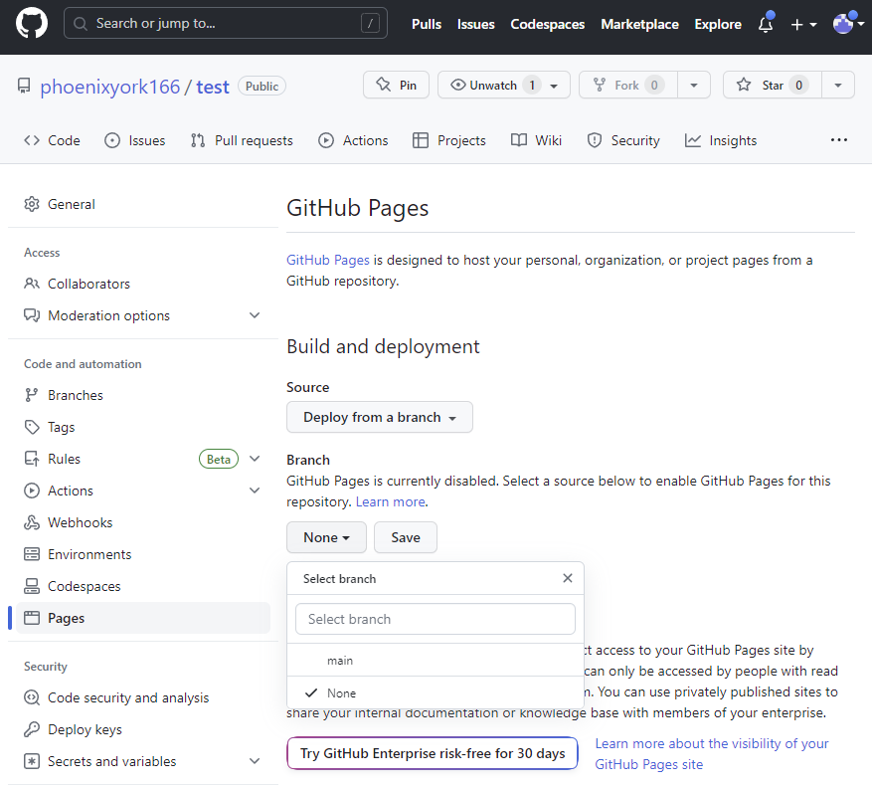

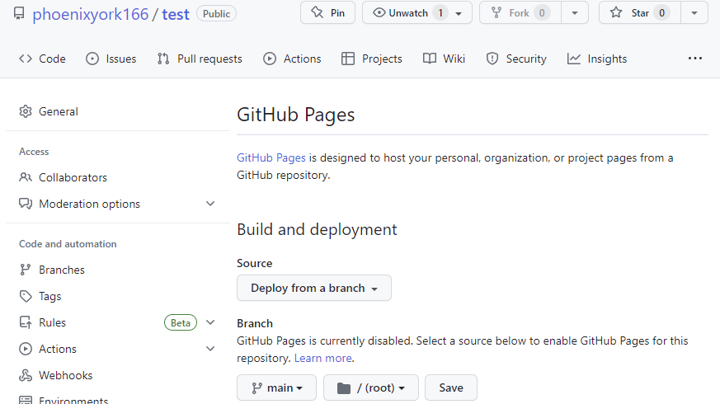

*Save

16. This will give you a Github Repo url for deployment:

<https://phoenixyork166.github.io/robofriends/>

17. Optional checking git repository with vscode:

git remote -v

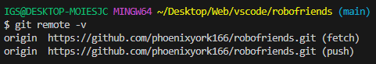

// To check current remote url

git remote -v

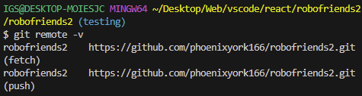

// To add remote url

git remote add origin URL

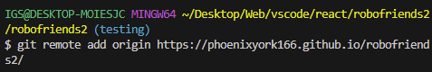

18. Follow create-react-app.dev documentation for React app deployment on Github Pages:

<https://create-react-app.dev/docs/deployment/>

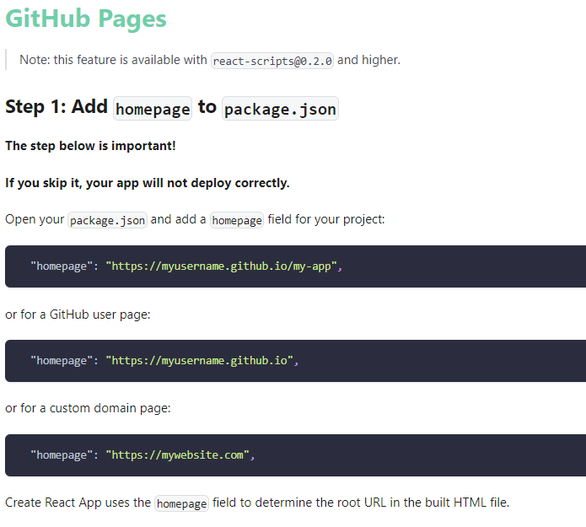

19. Go to our package.json

add "homepage": "<https://myusername.github.io/my-app>",

under "name": "project name",

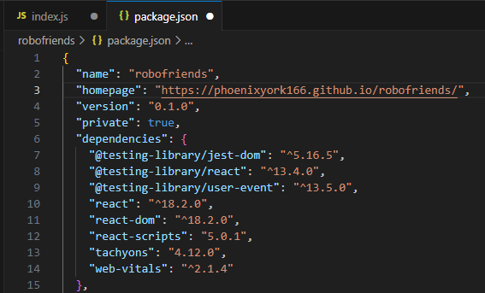

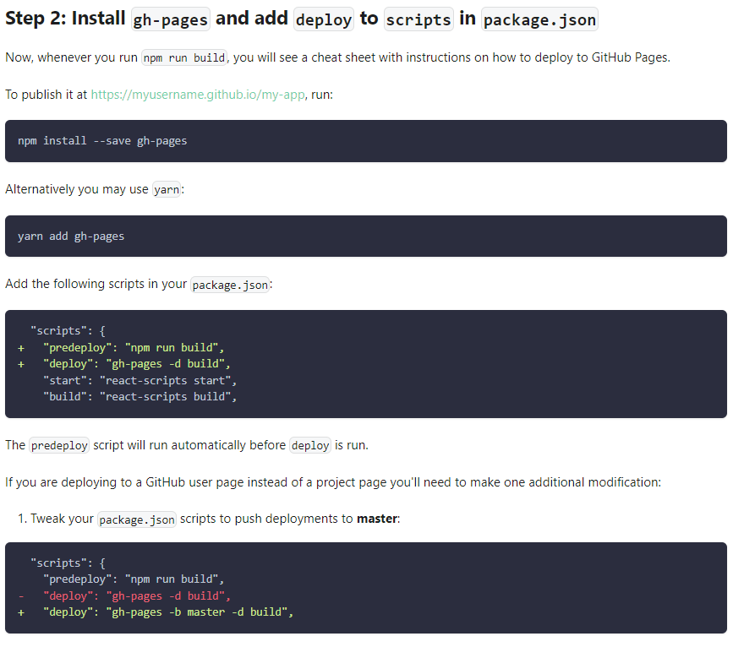

**\*\* Follow me! \*\***

20. cd project folder ->

npm install --save gh-pages

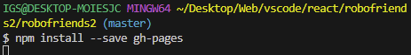

21. npm update gh-pages

22. Add scripts to

"scripts": {

"start": "react-scripts start",

...,

"predeploy": "npm run build",

"deploy": "gh-pages -d build"

}

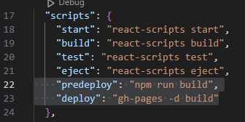

22. npm run deploy

This should create a 'build' folder in vscode & then publish your app to your

Github Repo url for deployment:

<https://phoenixyork166.github.io/robofriends/>

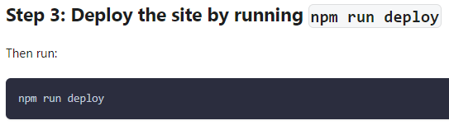

====After npm run deploy

**23. Our project is now published**

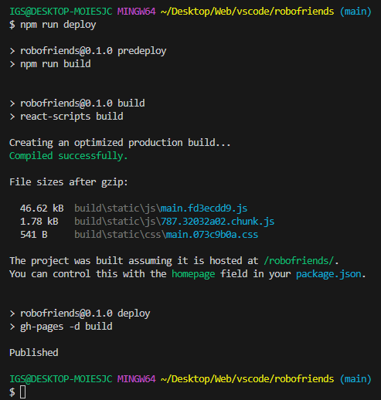

**24. Go back to our github repo -> Settings**

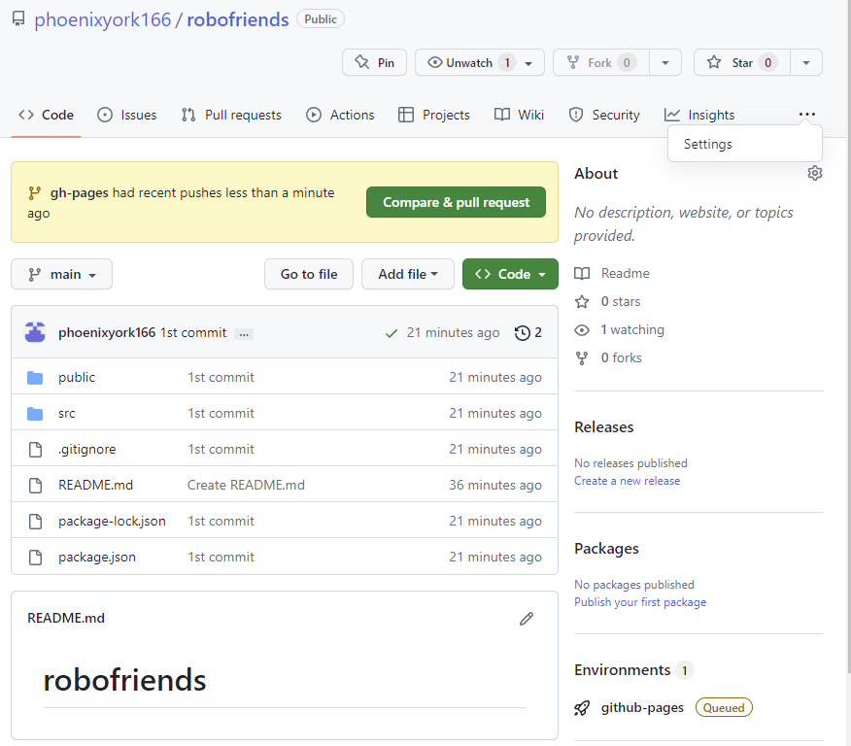

**25. Select Pages**

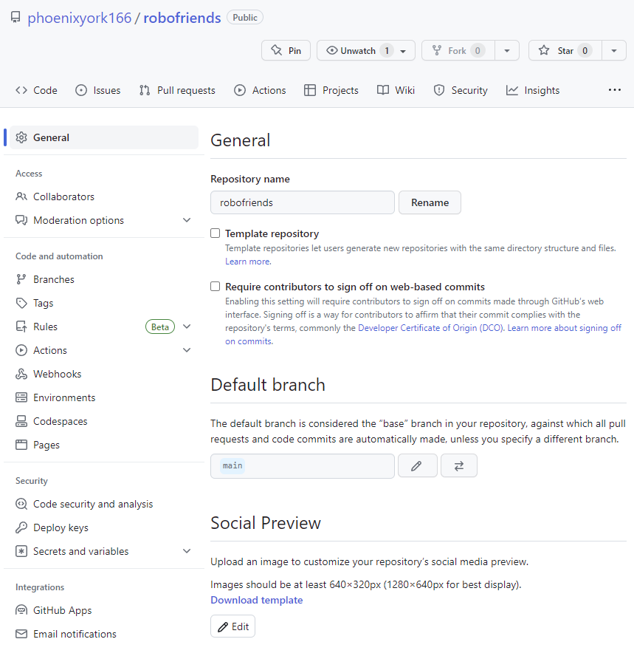

**26. Under Pages -> Build and deployment**

**Branch -> this time, we select gh-pages -> Save**

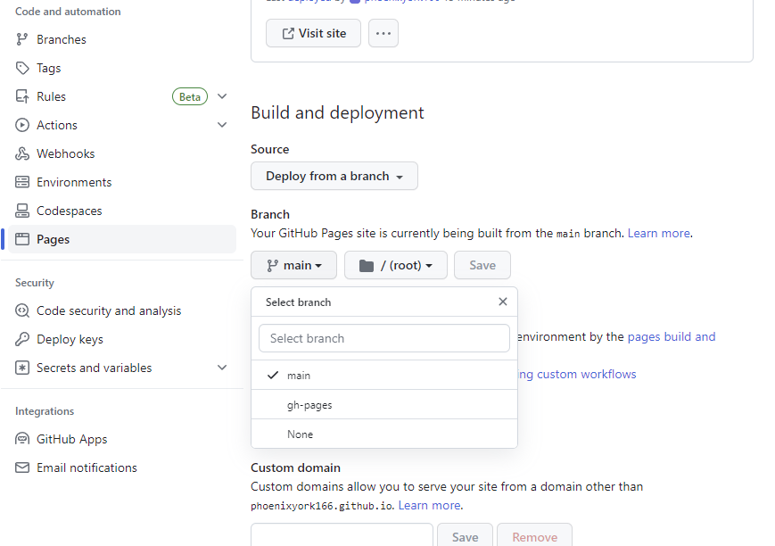

**5. Refresh our project url:**

<https://phoenixyork166.github.io/robofriends/>

Now, our React App is live!

